**Amazon AWS**

**AWS Elastic Beanstalk**

It is possible to create Postgres db with elastic beanstalk for free. And after giving the db link in application.properties file, it is possible to upload gradle based java jar file in Elastic Beanstalk. It can be deployed which will give an AWS link to access the application. These are the following steps to use Elastik Beanstalk.

First, create a Postgres db using RDS,

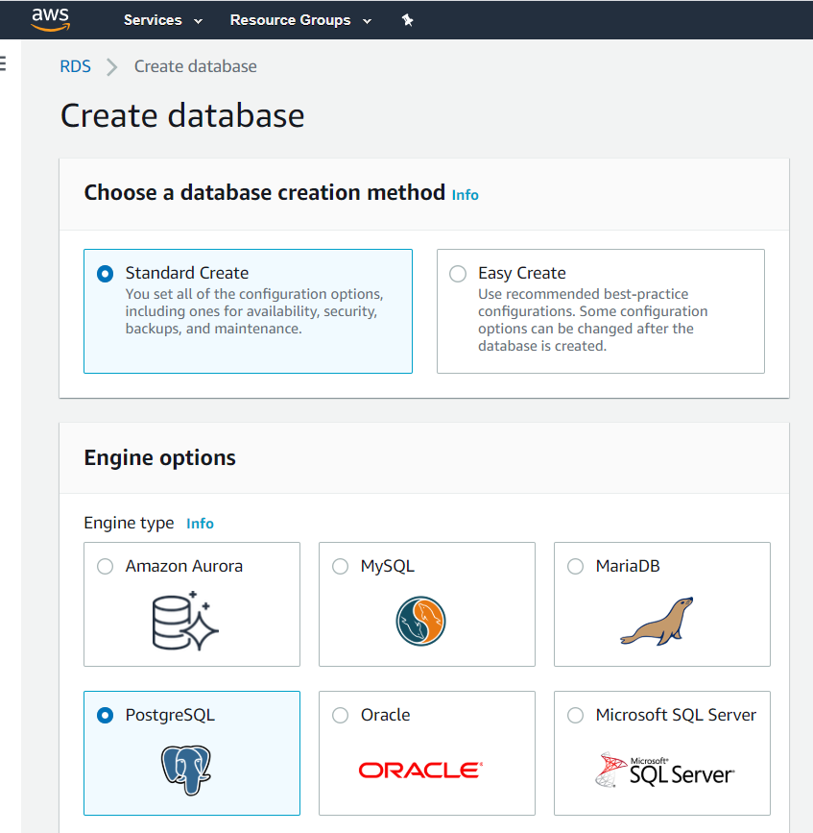 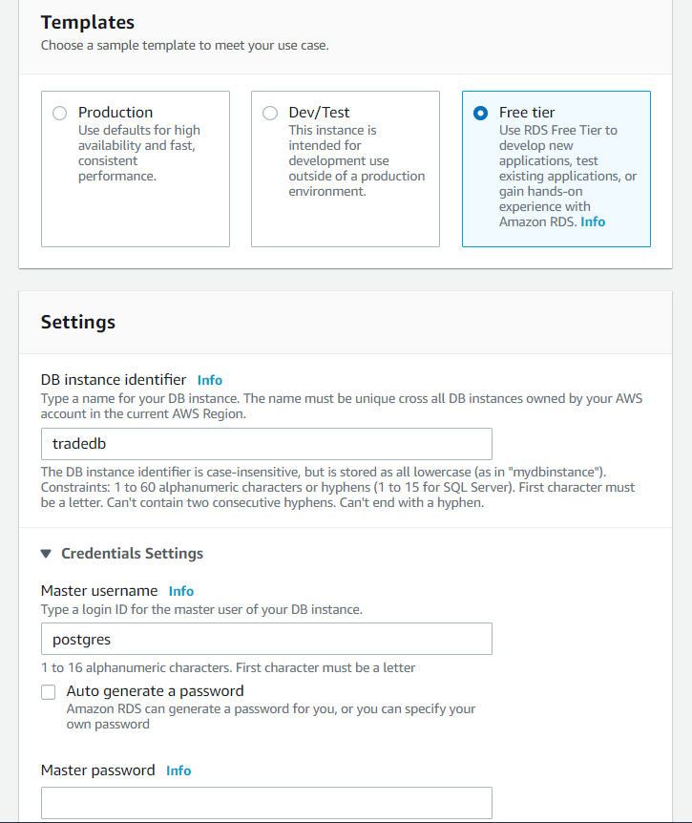

It will create a postgres db like this.

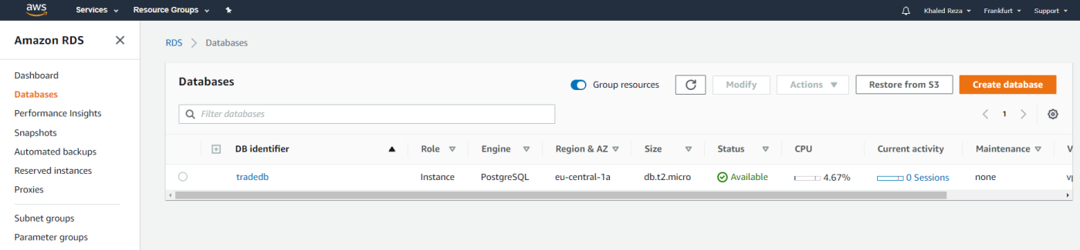

It gives an access endpoint and selected port for the db which can be used in the application,

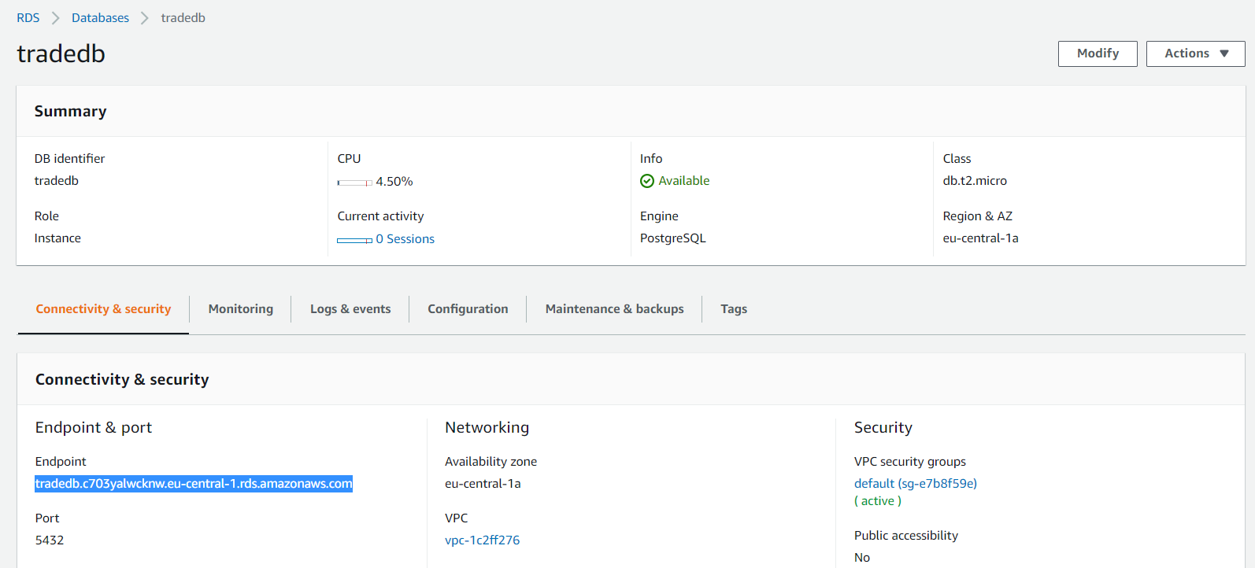

This endpoint has to be set on the application.properties to get access of postgres db. And the application port number has to set 5000 like following,

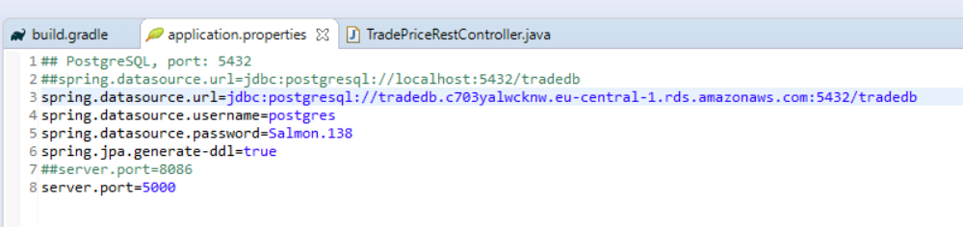

Then I have to create a new jar using gradle build tools,

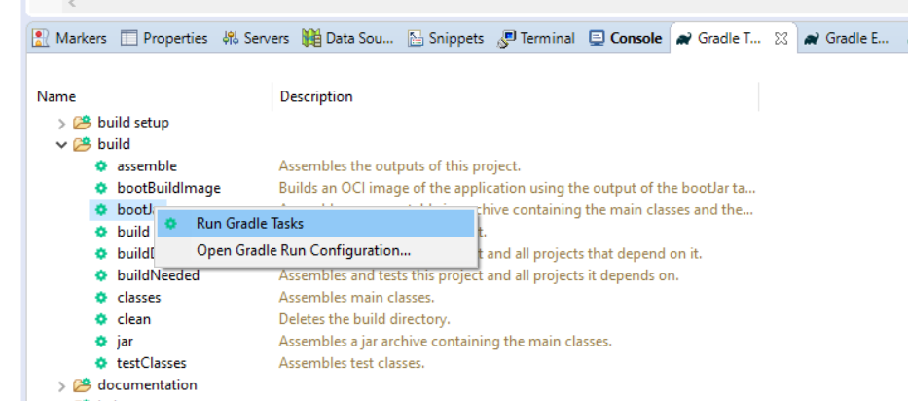

It will generate a new jar file containing all the dependencies, under build/libs folder since destination is not configured.

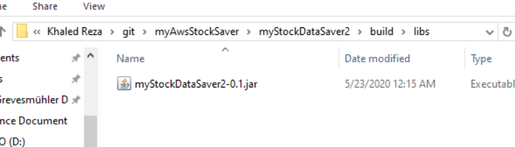

If you click on services and select Elastik Beanstalk from the history or search it from the browser,

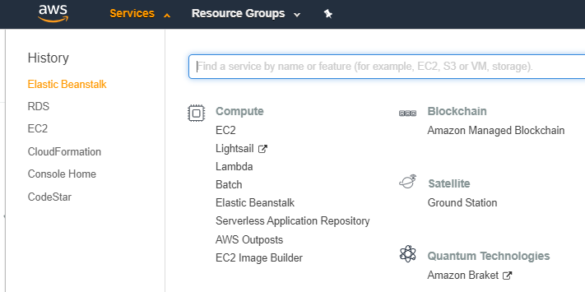

Under Elastik Beanstalk, you have to create a new Environment, select web server environment.

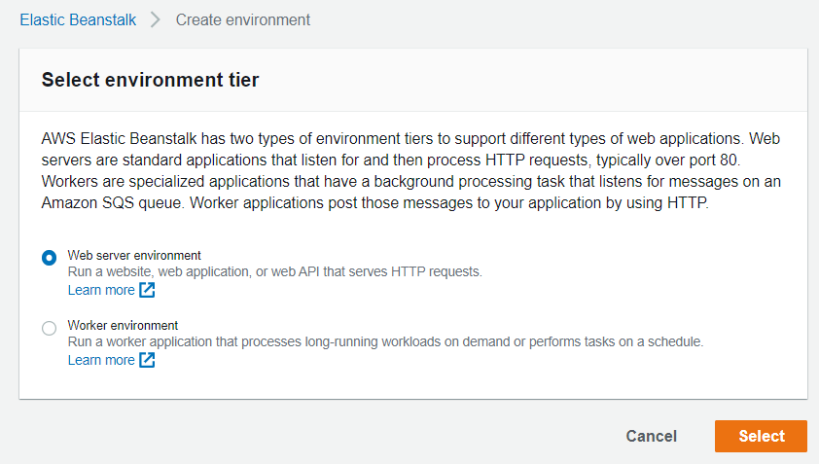

Provide the application name and it is optional to give a key value to find it when there are many app.

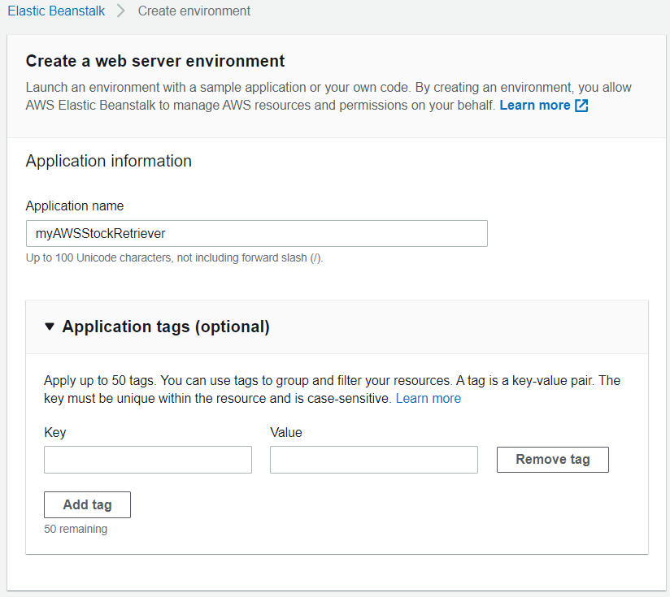

Select environment, it is possible to write some selected domain and check if it can be available and select programming language platform (Java 8 running on 64 bit amazon linux)

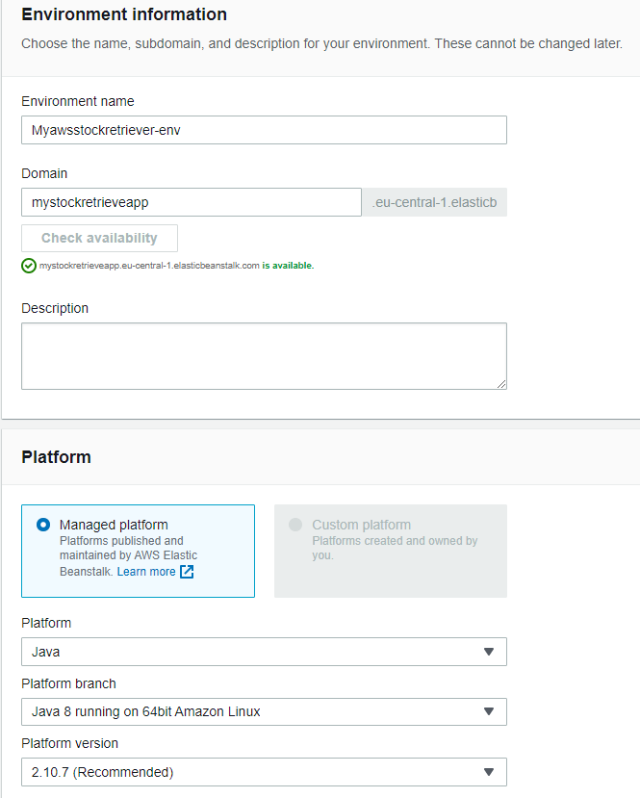

Select source jar file to upload it and finally create app,

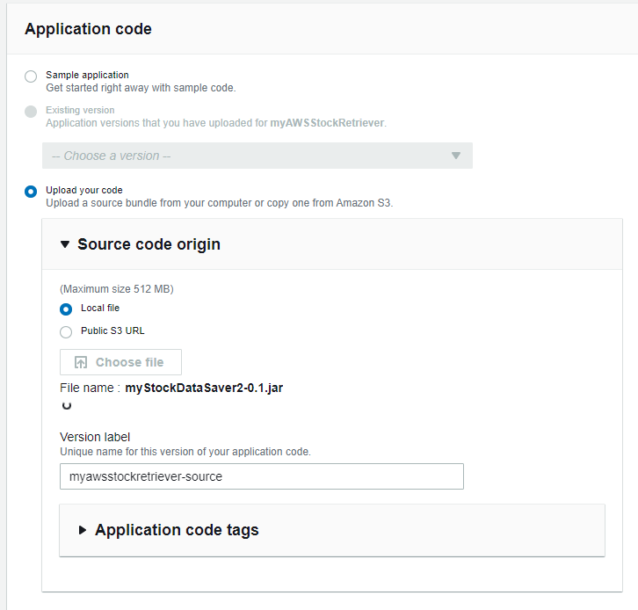

It creative an applicaton as follows,

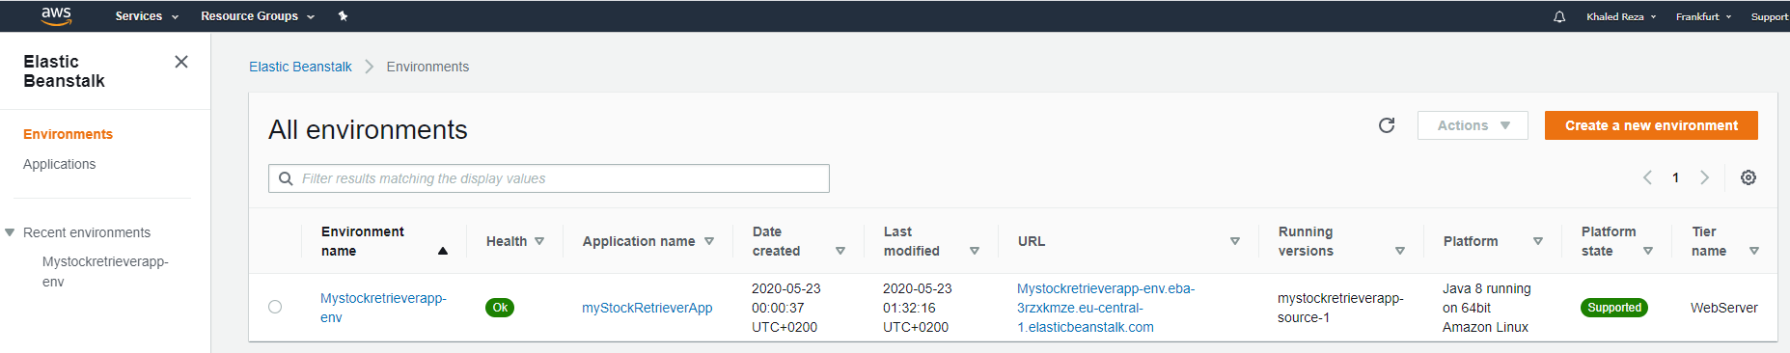

To make it correctly deploy and work with postgres, we have to tell postgres to allow security group from our spring boot application. For that you have to search for EC2 and click Security Groups.

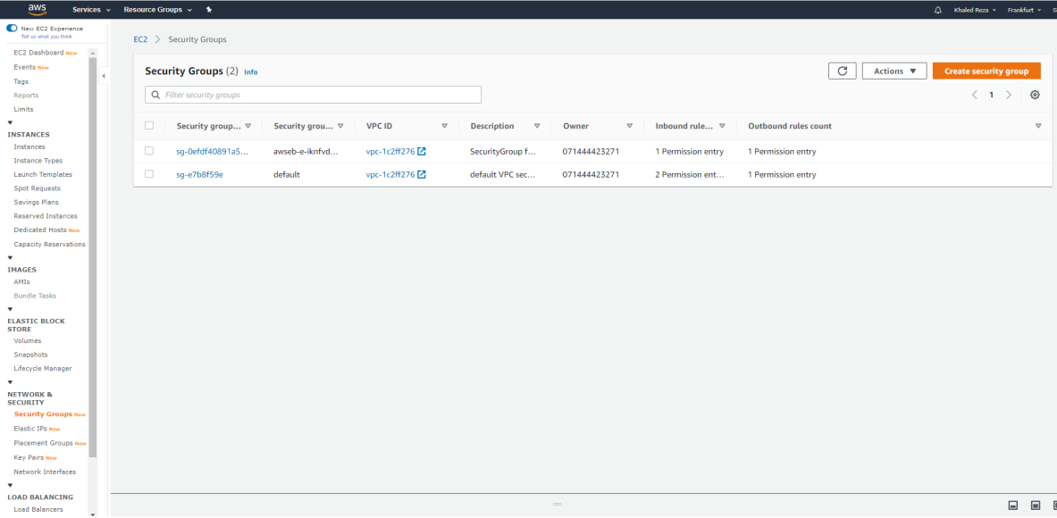

You have to select and **copy** the Security group id from our spring boot application and insert in to the inbound of Postgres instance (by edit). And then save rules.

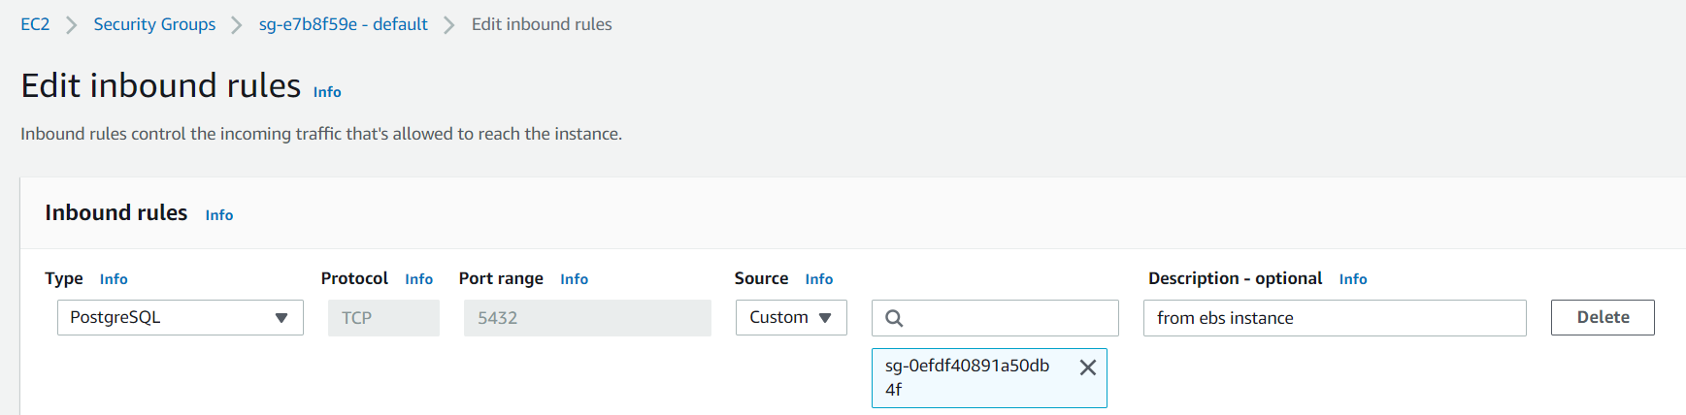

If you go back to elastic beanstalk, there should be already changed application after taken that db inbound rules changed. Now, testing the application should already work with the application link.

[Mystockretrieverapp-env.eba-3rzxkmze.eu-central-1.elasticbeanstalk.com](http://mystockretrieverapp-env.eba-3rzxkmze.eu-central-1.elasticbeanstalk.com/)

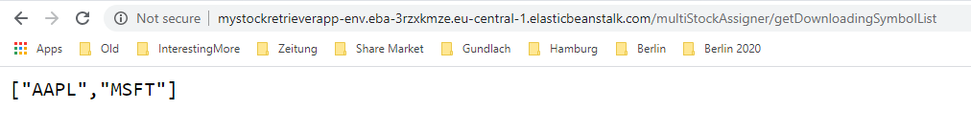

It you need to give changed version of jar file, it possible to change it by simply click Upload and deploy.

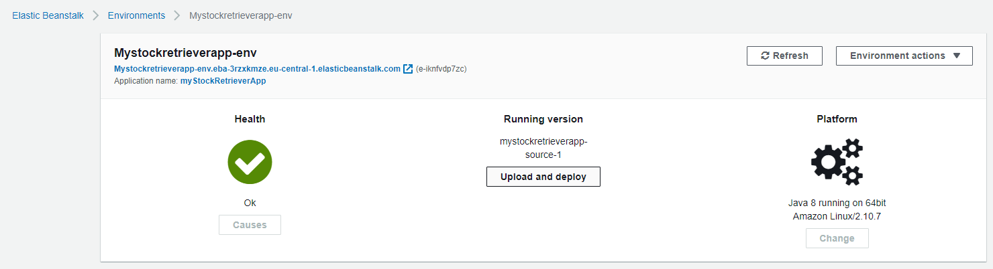

It is possible to see application log message by Logs.

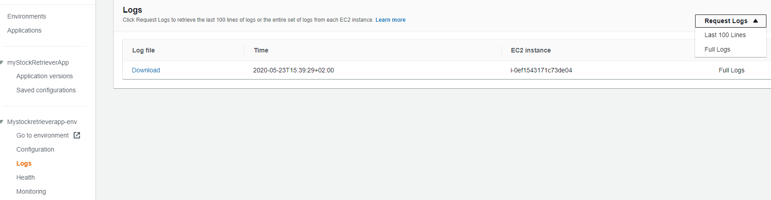

**AWS CodeStar + Githhub**

Using codeStar, it is possible to make complete DevOps like Jenkins. It is possible to create maven project in githhub or amazon codecommit. And then you can add AWS plugin in eclipse and you can bind them both together and after every commit, you can configure to build and deploy your application. You can also configure your developer role in this development environment.

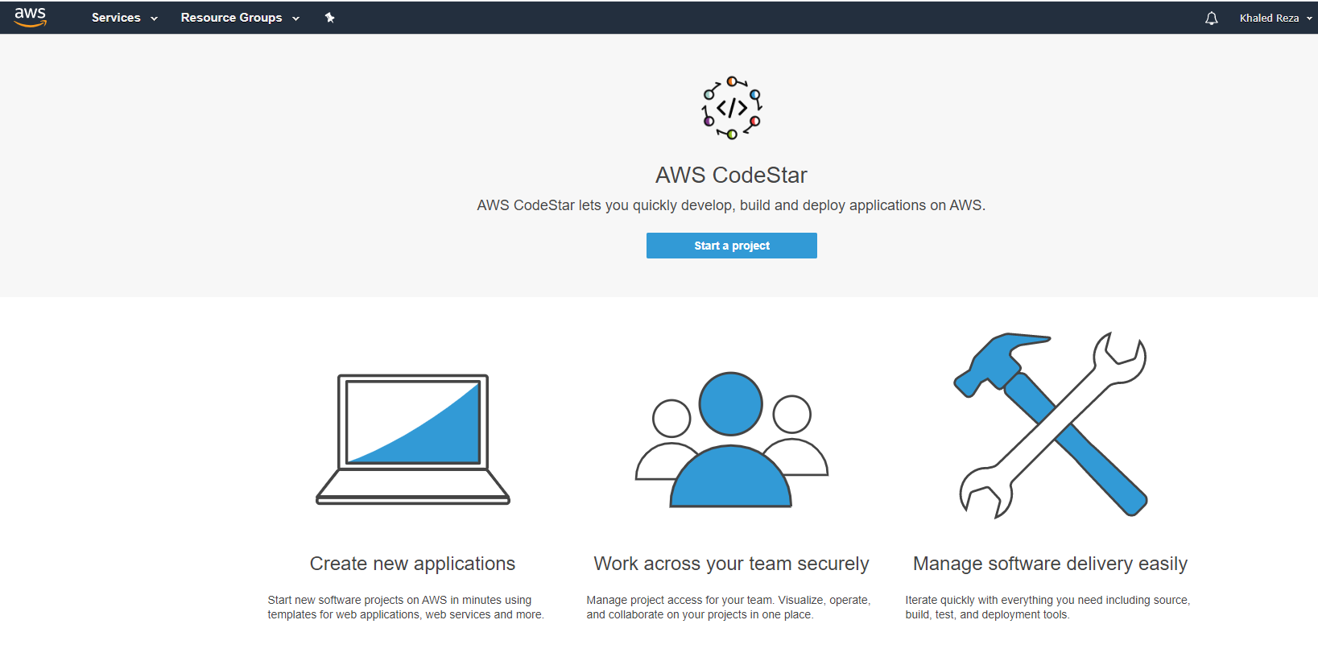

By clicking Java programming language type, it gives the opportunity to get lots of Spring options. My desired option is Java Spring Web Service with Elastic Beanstalk.

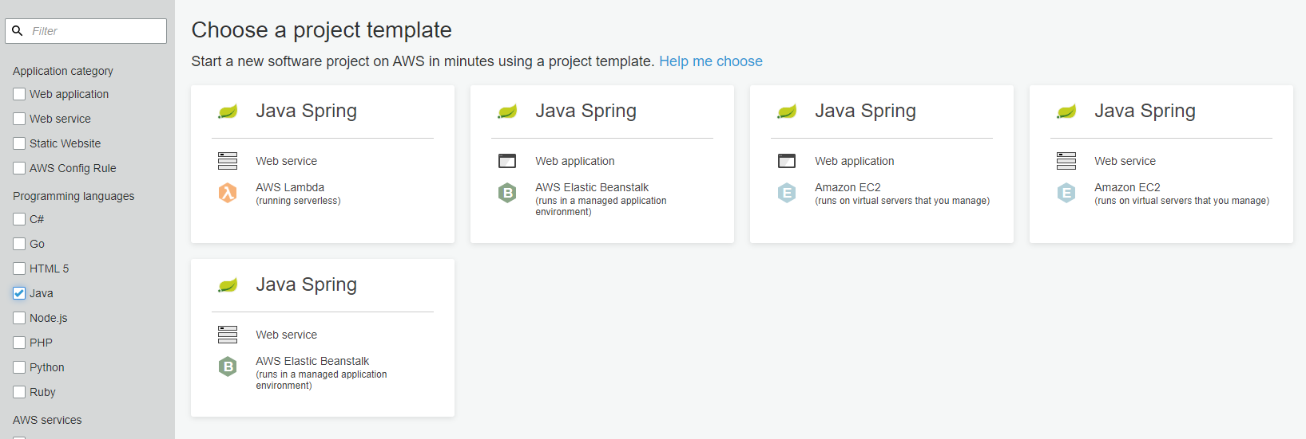

Then I wanted to use Githhub and I had to give my credential of my Githhub to get permanent connection with AWS. It will automatically detect my commit form Githhub.

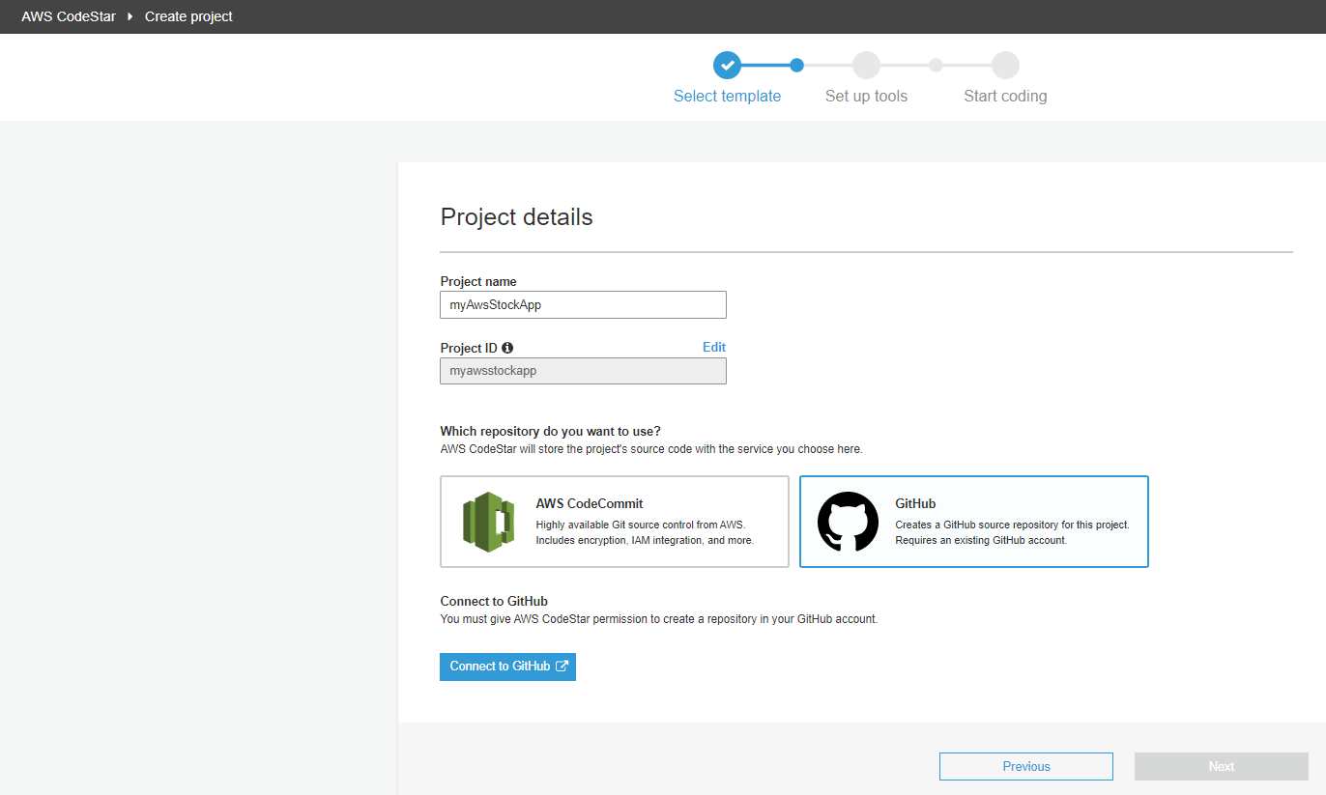

Authorized AWS CodeStar.

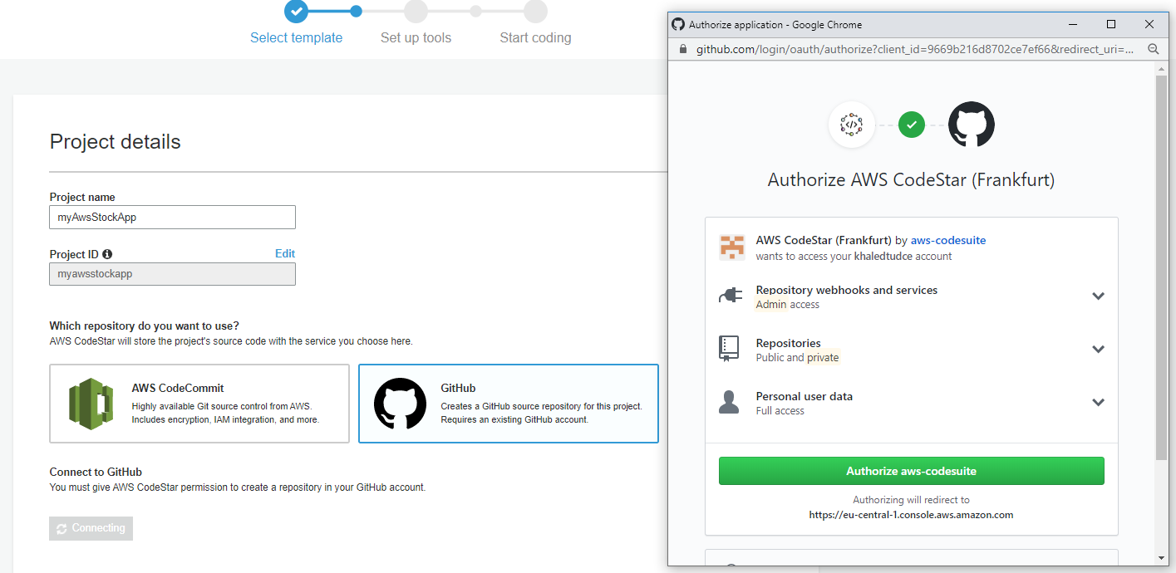

To create a project, I had to provide again key value pair which was not already there for me and I had to make it again as in the below picture.

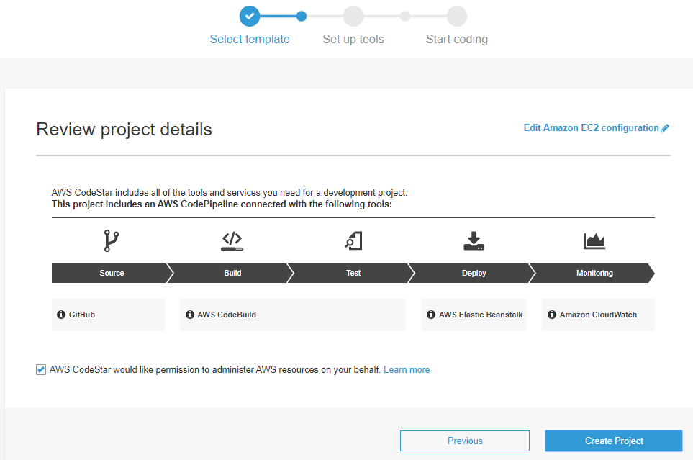

With EC2 Security Groups, I had to generate Key Value pair.

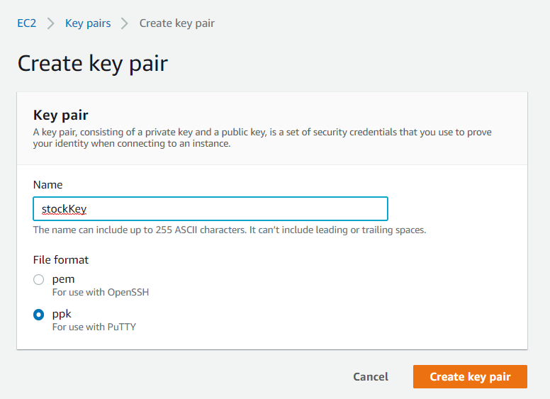

After generation of key, I get back and select it before project generation.

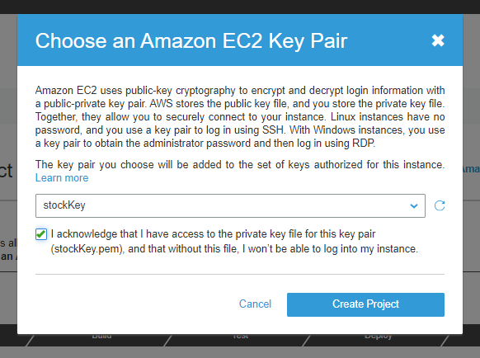

Finally the project is generated.

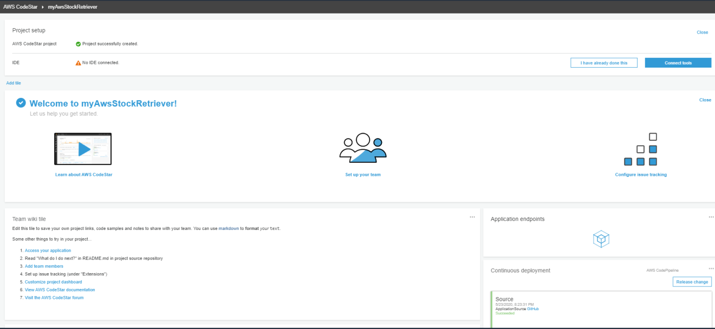

It took a while to do project generation. It provided a git link connect it with AWS, Eclipse.

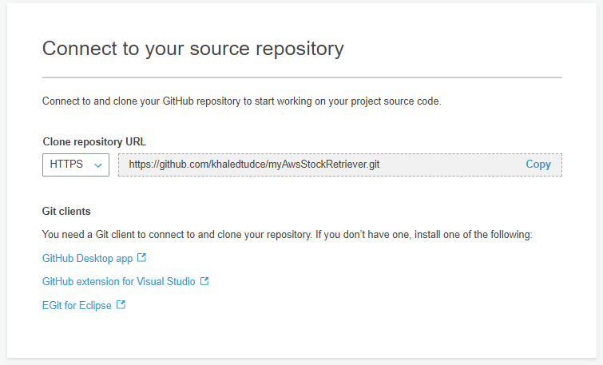

To make connection with Githhub and My eclipse and AWS, I had to install EGit in my Eclipse.

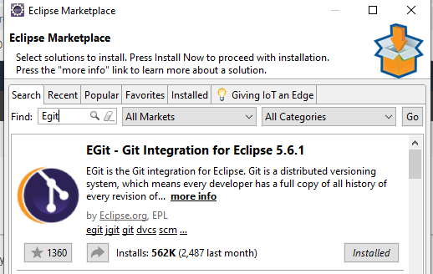

New generated repository was cloned into local repository.

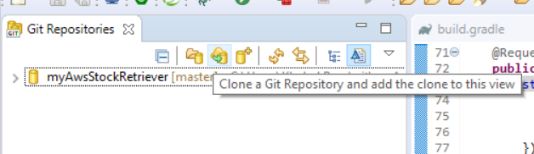

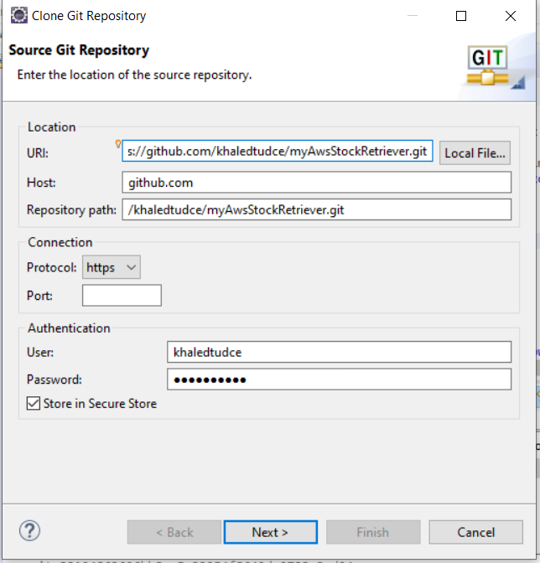 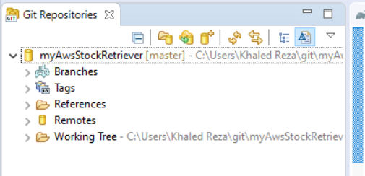

Its time to generate new project using this cloned repository. For that I had to import from Git,

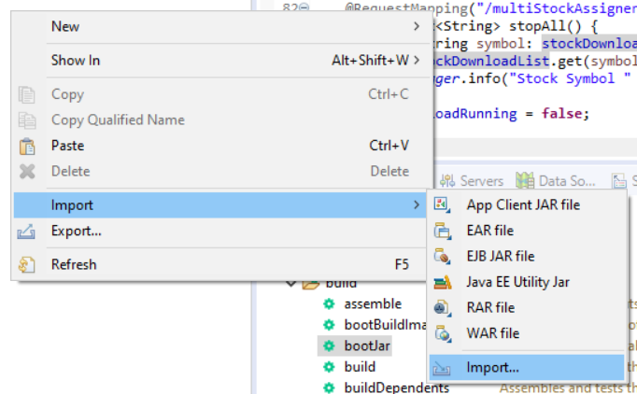 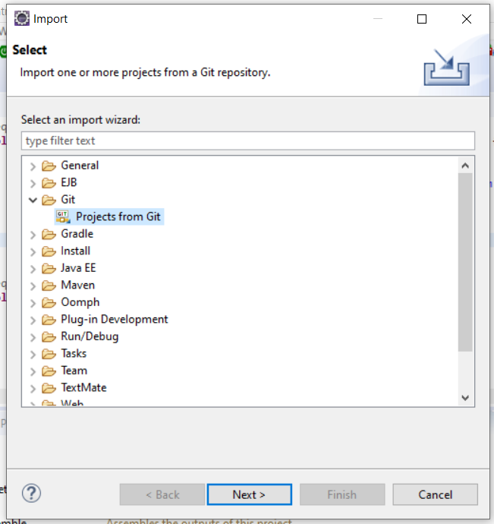

Seleted Repository

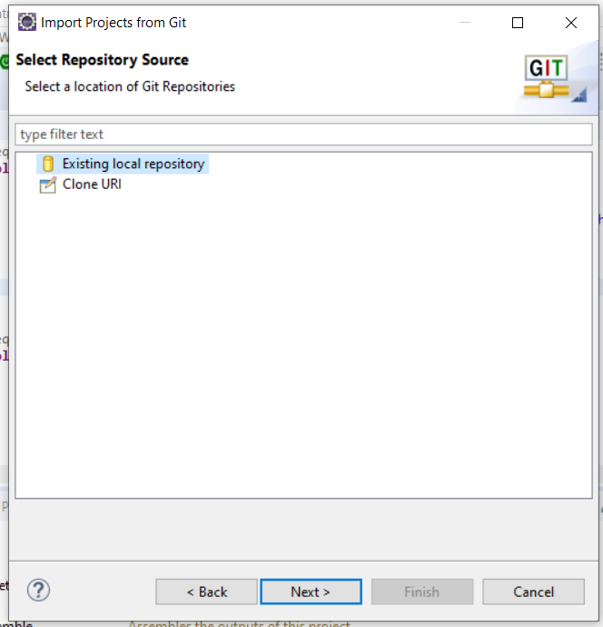 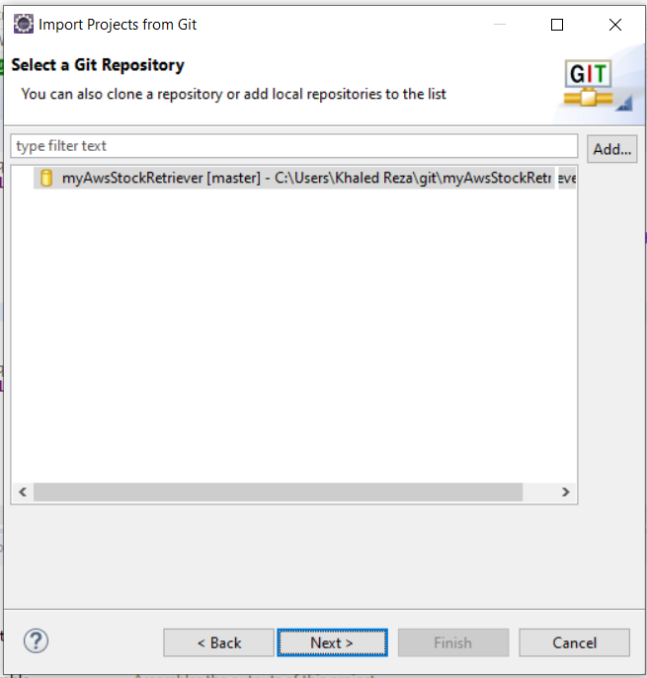

Finally imported as a general project. It will download all the files from auto generated files from Githhub.

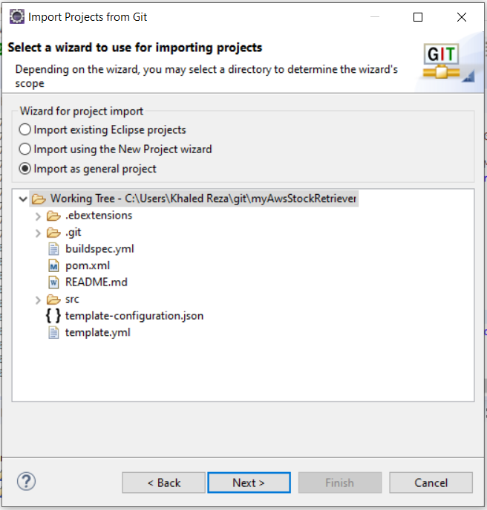

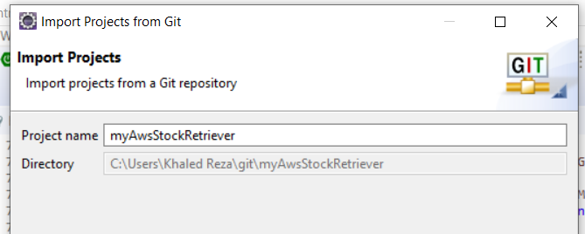

Finally, that’s how the project looks like in Eclipse after import.

Project structure looks like not properly organized with package and when create new class, it says,

[“Source folder is not a Java project” error in eclipse](https://stackoverflow.com/questions/11719545/source-folder-is-not-a-java-project-error-in-eclipse)

Solution: With the Terminal go to pom.xml location and execute “**mvn eclipse:eclipse**”. It will download all the dependencies and organize packages correctly.

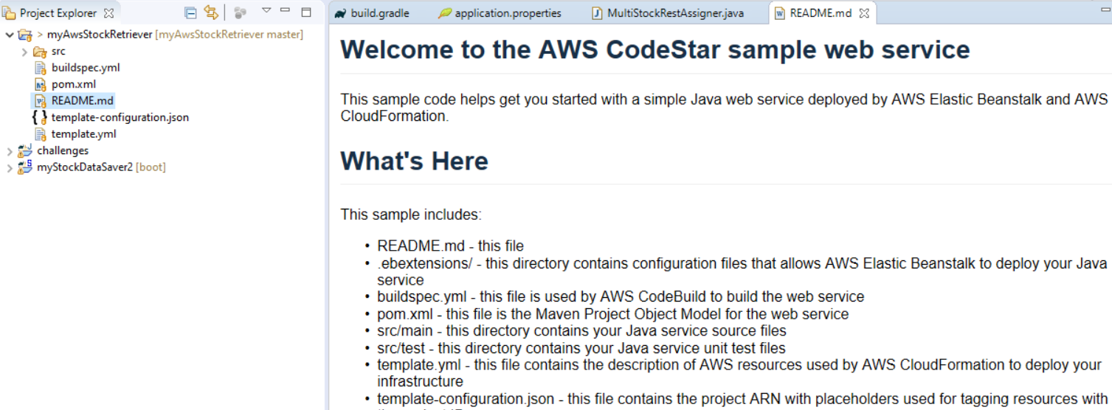

Right click and configure maven build (maven **compile**),

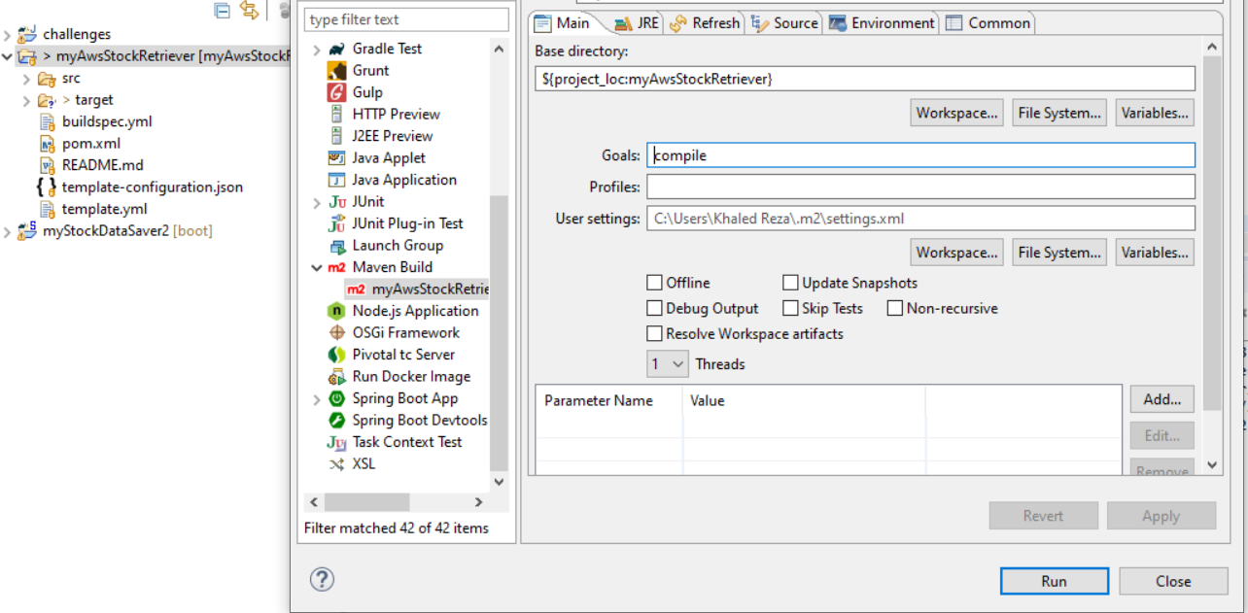

Commit changes in Eclipse.

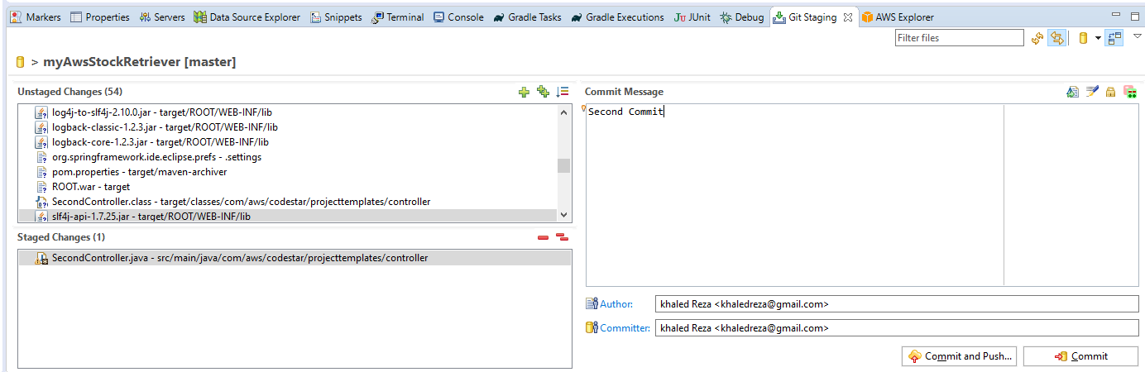

Came commit directly to the AWS and it made build and deploy directly.

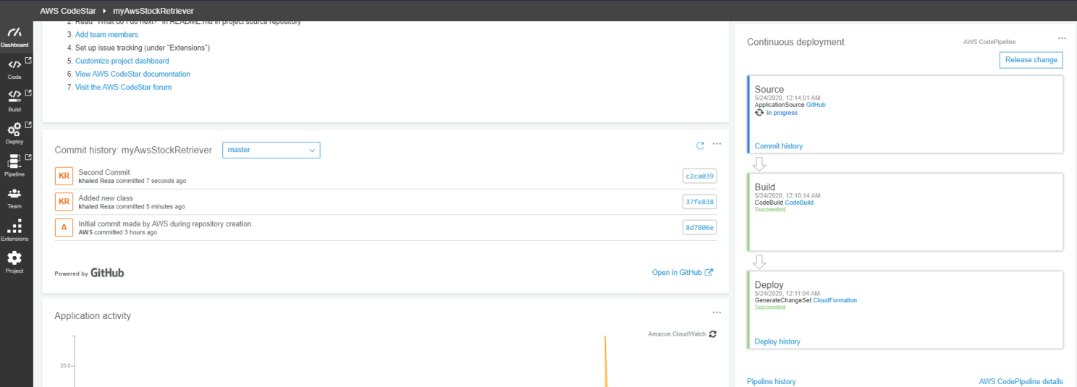

**Another way to manage development (with AWS CodeCommit)**

This is the situation when we generated an AWS project using AWS Codecommit repository. I had to install AWS Toolkit for Eclipse from Marketplace. After installation it asked for credentials, I provided this which was wrong, I had to generate Key from AWS again later.

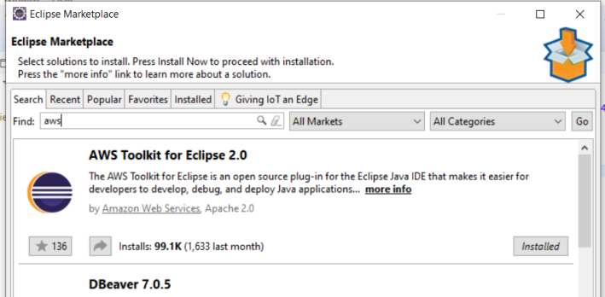 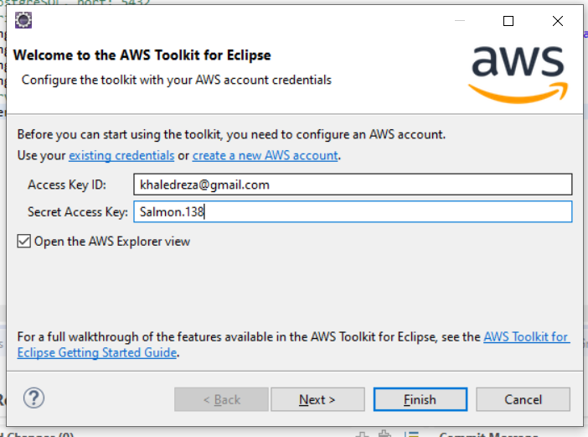

It provided one block in the import wizard called AWS. It is possible to import AWS project using this link.

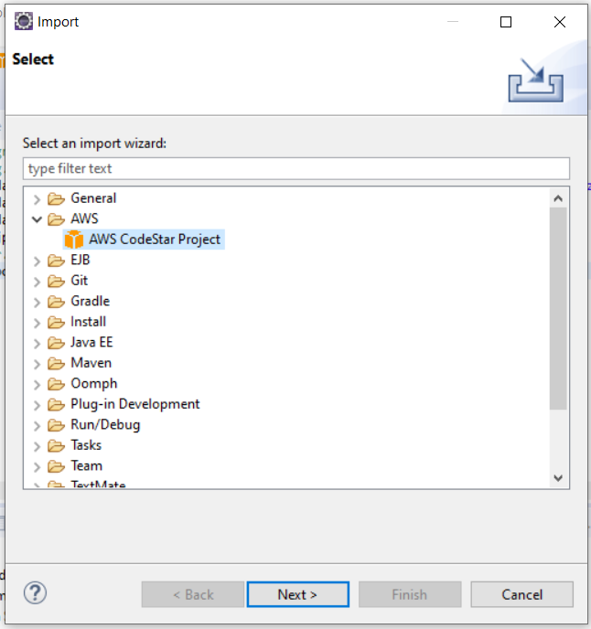

I had to generate security credential to get accepted.

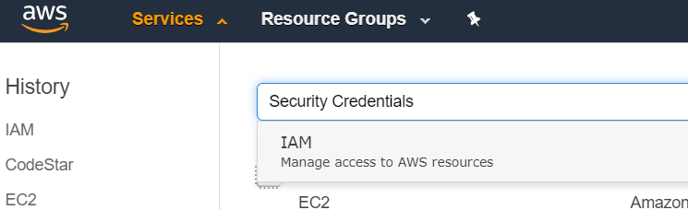

I made an user as follows. And gave him full right of access code. 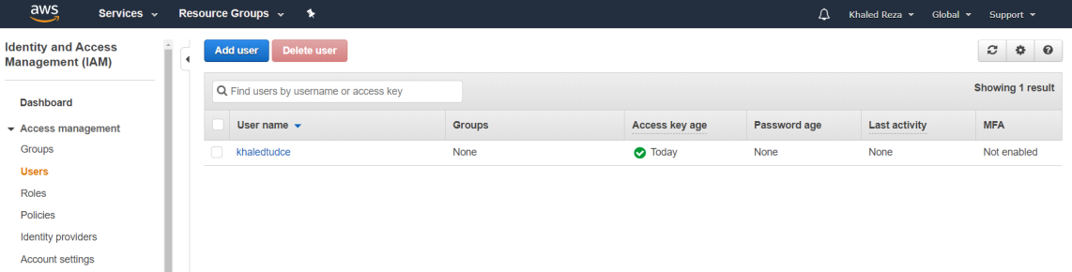

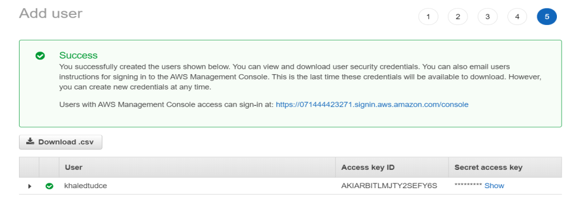

By clicking Configure AWS profiles, you can give again (previously give wrong) Access Key Id and Secret Access Key. Without them, the Next button was not accessible.

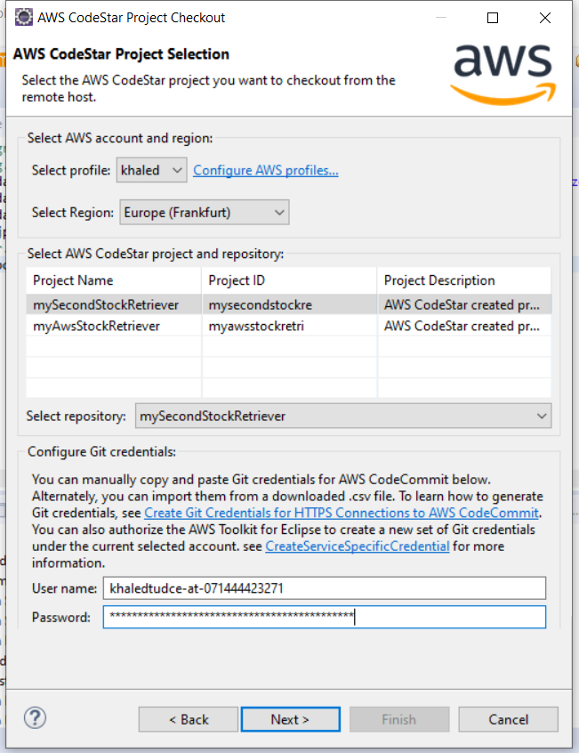

Both of these Access Key Id and Secret Access Key are given.

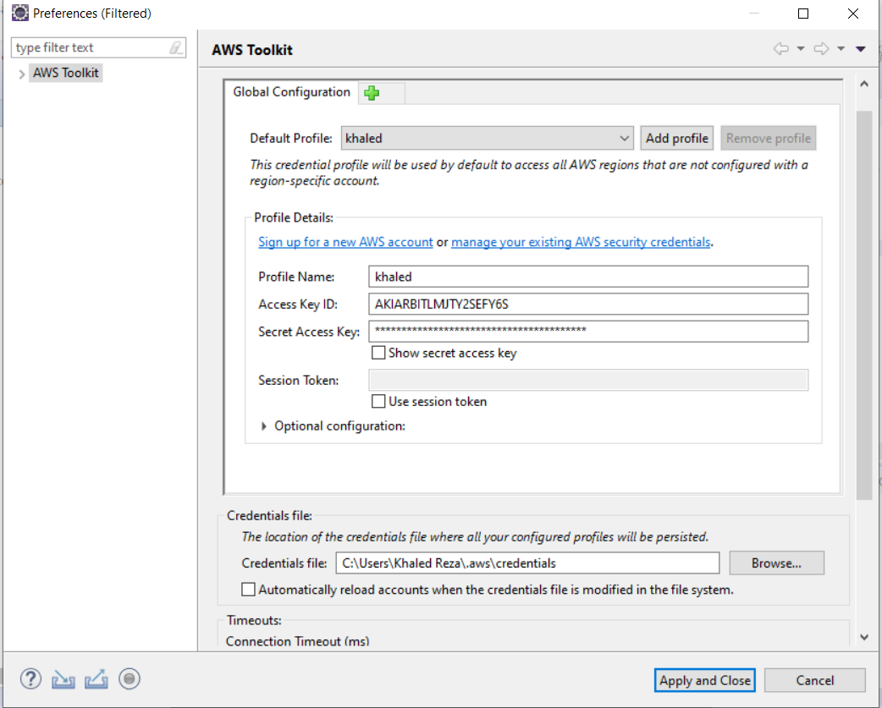

To generate HTTPS Git credential for AWS CodeCommit, I had find it. 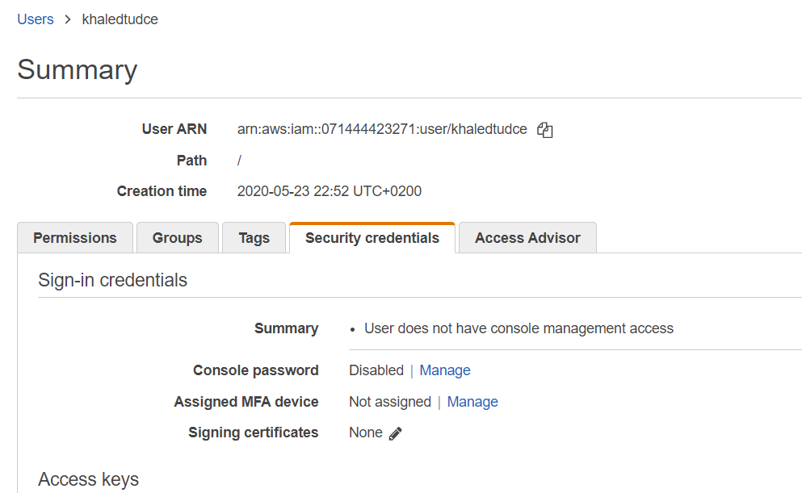

I had to find it under generated **users** and under Security credentials.

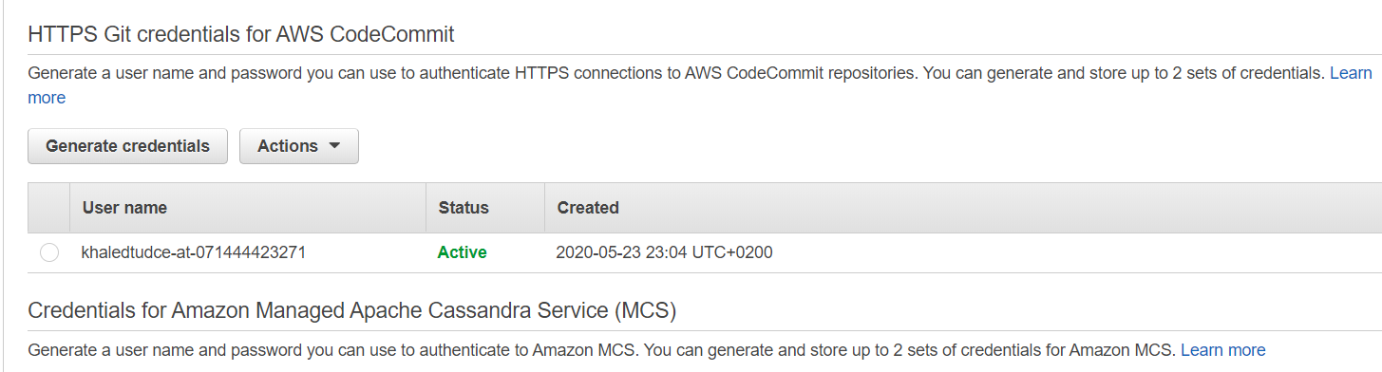

After giving HTTPS git credential and AWS profiles credential, finally the AWS CodeStar project checkout was successful and the project was look like this.

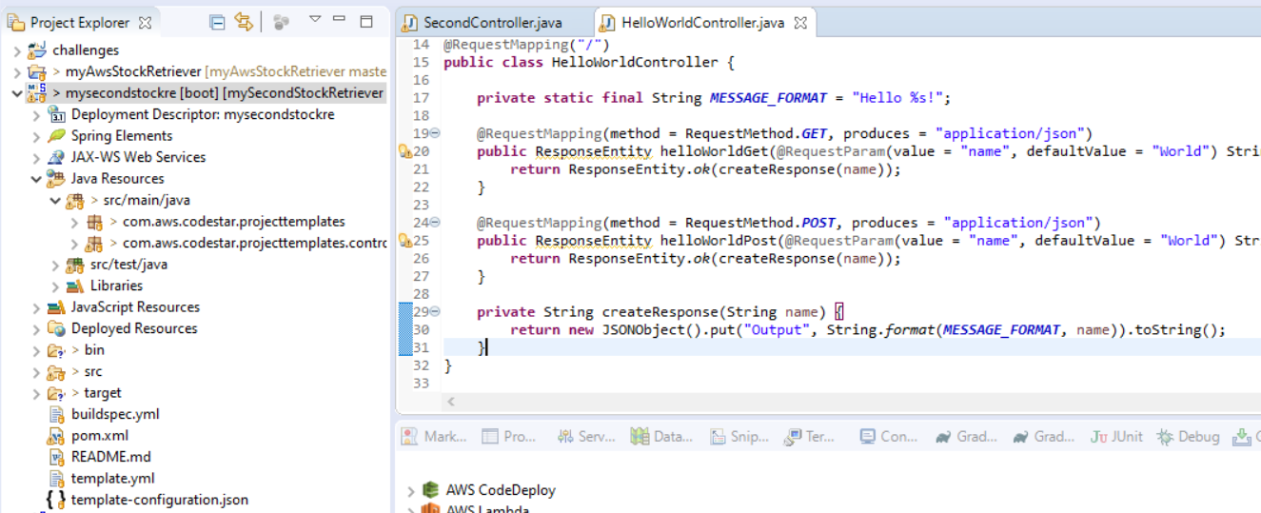

After some changes, I made a commit.

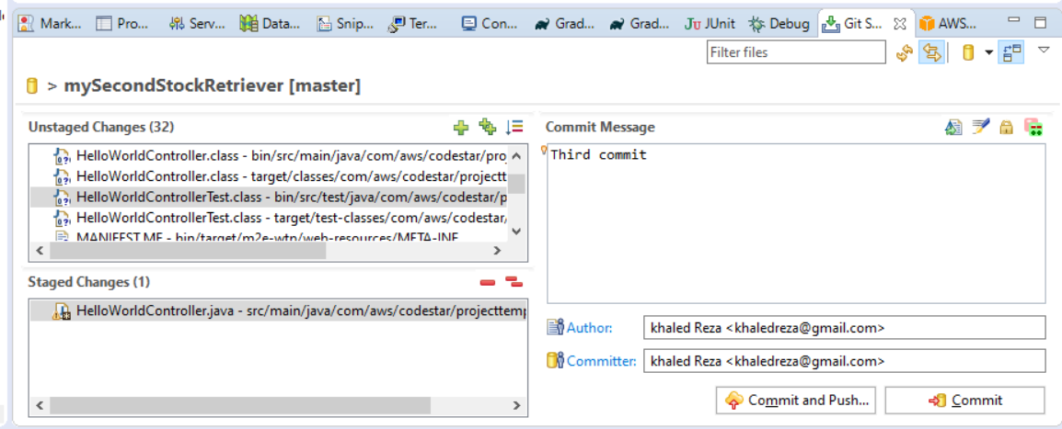

You can see the Eclipse commit directly on the AWS CodeCommit.

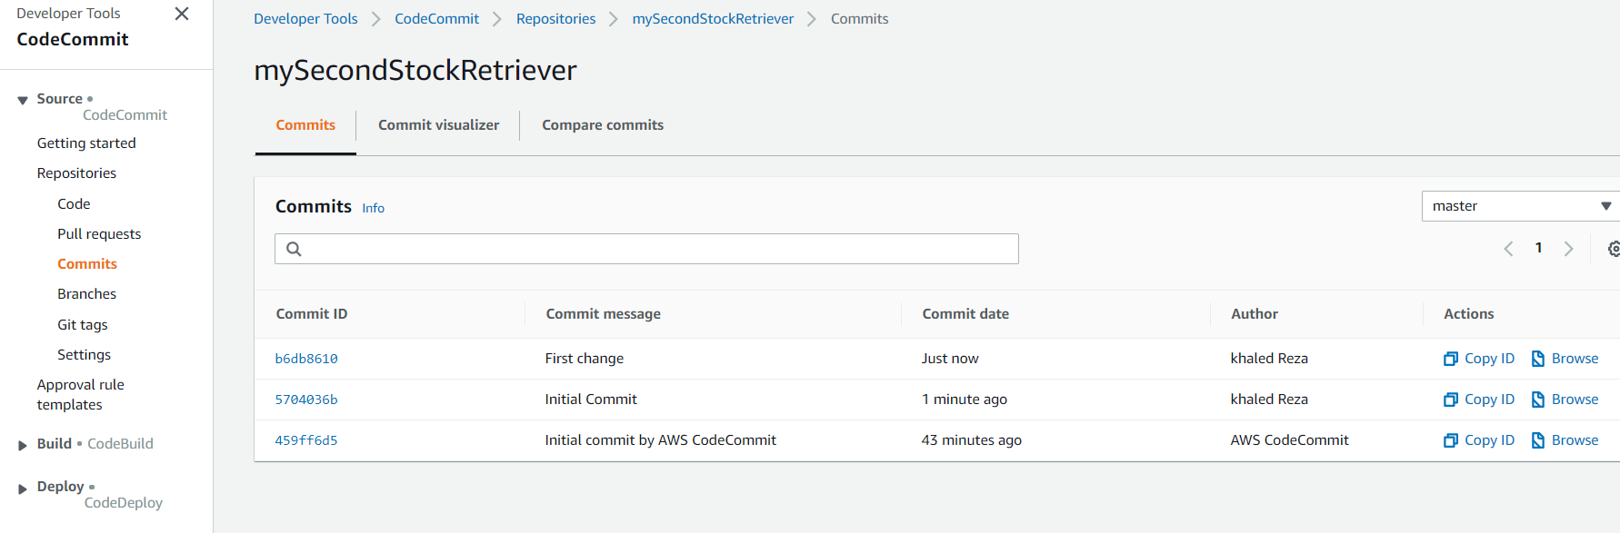

Further more, using AWS tools in Eclipse, you can directly your project to AWS Elastic Beanstalk and some more as in the following.

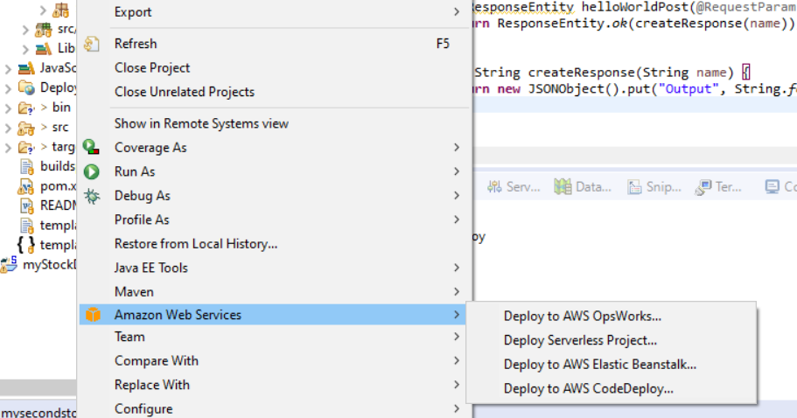

**Docker Hub and Elastik Beanstalk**

It is possible to generate docker image image of database (Postgres, Mysql) and Spring Boot image with linked DB. This can be deployed in Docker hub. Finally with Command Prommt, it is possible to directly upload these dockerized images deploy AWS directly to the Elastic Beanstalk.

**AWS EC2**

Have to do lots of configuration to deploy a project. For example, you have to specify what server you are going to use (e.g. Tomcat)

**Java Eclipse Shortcuts**

**General:**

**Windows + t**: next opened application

**Ctrl+3**: Google chrome no 3 tab

To Take a **Screenshot** of **Part** of Your **Screen**

**Windows** + Shift + S

**Refactor**

**Alt+Shift+L:** Extract a local variable

**Cntl+h:** Text search in whole project

**Ctrl+F11:**If you want to rerun the same test method, just press

**Alt + up:** Shift a line or selected method to upwards

**Alt + down:** Shift a line  or selected method to downwards

**Cntl+Shift+o:** Organize all the imports

**Cntl+o**: to see the list of members of a class

**Alt+Shift+m**: extract a method from selected code

**Refactor method parameter**: select variable and then right click, go to refactor, Introduce parameter.

**F2 : rename file**

**Ctrl+space**: open help for that error

**Ctrl+1**: suggestion for the error help

**Ctrl+/**: comment that line

**Ctrl+M**: maximize window or minimize window

**alt+shift+i**: Inline variable/method/constant

**alt+shift+R**: Rename method or variable for whole project

**alt+shift+X, T**: Run JUnit tests

**Ctrl+alt+down**: copies current line or selected lines to below

**Ctrl+alt+up**: copies current line or selected lines to above

**Ctrl+shift+L**: brings up a List of shortcut keys

**Ctrl+D**: Delete a line

**Navigate**

Go to the source file:**Shift+alt+w** and then select Project Explorer

**Ctrl+Shift+R**: open any file quickly without browsing for it in the package explorer

**Ctrl+shift+T**: open a type (class, interface)

**Ctrl+O**: go directly to a member (member, variable) of a huge class

**Ctrl+L**, enter line number: go to line number N in the current source file

**Ctrl+Q**: go to the last edit location

**Ctrl+T**: go to a super-type/sub-type

**Ctrl+Alt+h:**Opens the call hierarchy

**Ctrl+F7:** Switch to next view

**Ctrl+Page down:** Show/open next file from right sight

**Ctrl+Page up:** Show/open next file from left sight

**Ctrl+E:** Go to other open files/class

**Alt+left arrow**: Hope back the file and places previously you have visited recently

**Alt+right arrow**: Hope back the file and places you have visited recently (to forward)

**Ctrl+. :**move one to next problem

**Ctrl+, :** move one to previous problem

**Ctrl +** **Alt + G** : Select a string and search in any file of this entire project

**Search**

Ctrl + Alt + G can be used to **find** selected text across a workspace in **eclipse**

Ctrl + H and use file search using text

**GIT**

**Revert a single file from a specific commit,**

git checkout 3b0a0bb4390757e3e6637f10b071e651b23af5b3 myStockDataSaver/src/main/java/app/stockDataStore/SingleStockRunner.java



**Gradle**

[**Gradle: Could not determine java version from '11.0.2'**](https://stackoverflow.com/questions/54358107/gradle-could-not-determine-java-version-from-11-0-2)

As distributionUrl is still pointing to older version, upgrade wrapper using:

gradle wrapper --gradle-version 5.1.1

Note: Use gradle and not gradlew

[share](https://stackoverflow.com/a/54493187)[improve this answer](https://stackoverflow.com/posts/54493187/edit)follow

answered Feb 2 '19 at 12:42

[[](https://stackoverflow.com/users/239582/lupchiazoem)](https://stackoverflow.com/users/239582/lupchiazoem)

[lupchiazoem](https://stackoverflow.com/users/239582/lupchiazoem)

**7,158**44 gold badges3131 silver badges4040 bronze badges

* That works. The command updates my gradle wrapper version. Thanks. – [Daniel](https://stackoverflow.com/users/2695077/daniel) [Mar 29 '19 at 7:23](https://stackoverflow.com/questions/54358107/gradle-could-not-determine-java-version-from-11-0-2#comment97544092_54493187)
* Or just replace the version in gradle/wrapper/gradle-wrapper.properties distributionUrl=https\://services.gradle.org/distributions/gradle-5.1.1-all.zip Version 6 with JDK12 doesn't seem to work. 5.1.1 works fine, thank you. – [Liam Kernighan](https://stackoverflow.com/users/7313872/liam-kernighan) [Dec 14 '19 at 10:41](https://stackoverflow.com/questions/54358107/gradle-could-not-determine-java-version-from-11-0-2#comment104866822_54493187)

**Gradle command line tasks**

In eclipse, enter to the file location of your project and then press commands.

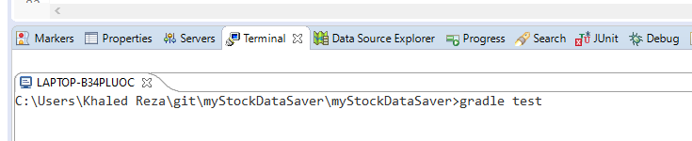

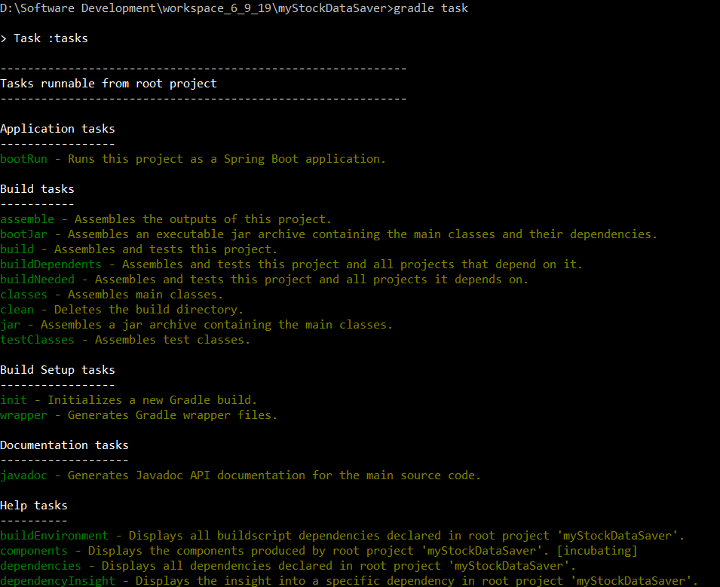

Gradle custom tasks, represented under Gradle tasks bar (group). Refresh it, if it does not show immediately.

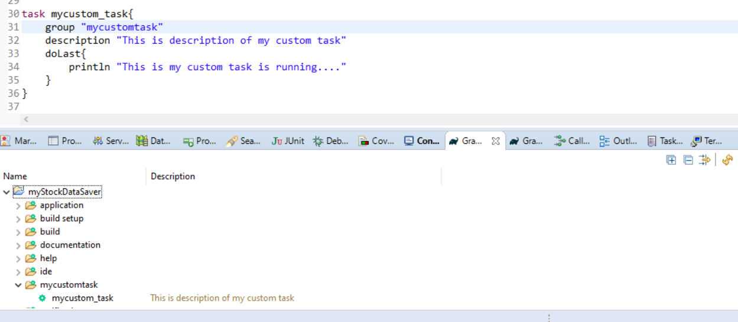

**The compile configuration has been deprecated for dependency declaration. This will fail with an error in Gradle 7.0. Please use the implementation configuration instead**

compile group: 'org.apache.httpcomponents', name: 'httpclient', version: '4.5.10'

implementation 'org.apache.httpcomponents:httpclient:4.5.10'

How to exclude (from consideration with gradle) some part of the existing library which is already came up with Spring boot? It should be just name of the jar file but without .jar extension.

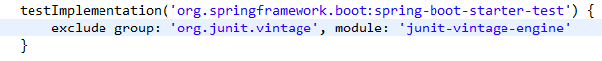

**Gradle build without test running,**

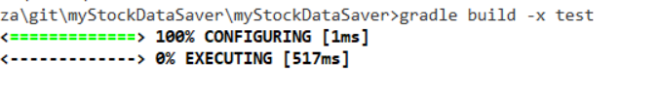

Create Jar without test running, 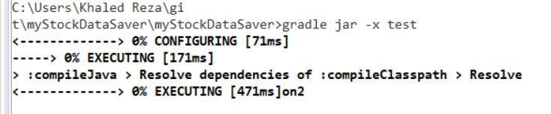

All Gradle commands in Eclipse,

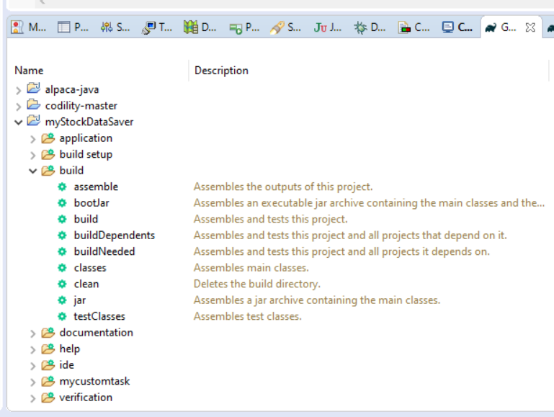

With right button click it possible to build in eclipse and also possible by Eclipse Terminal,

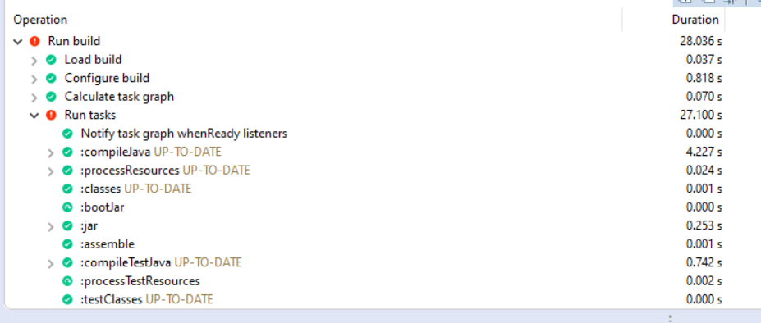

**Creates a jar file without running the test,**

gradle clean build -x test

**Docker**

Installed docker in the machine. I had to made the Virtualization enabled in the BIOS. I have windows 10 home, that’s why I had to install Docker Toolbox. I had to download updated version from githhub. After installation, now I have following things in my system.

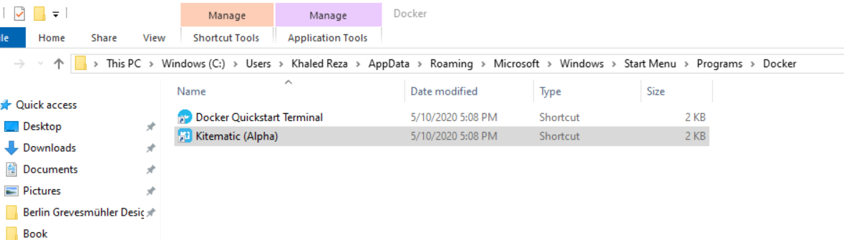

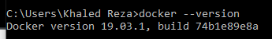

By maven install, we needed to generate a .jar file called docker-spring-boot, we can define that on the build path.

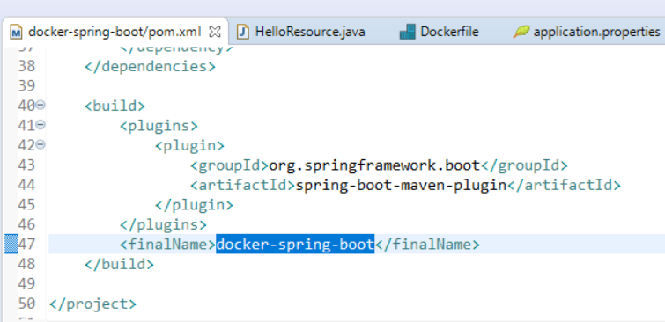 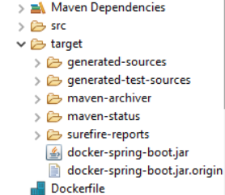

In the Dockerfile, you can say which version of openjdk to download and which .jar file to add and which port to expose and what is the entry point of this project (jar running command).

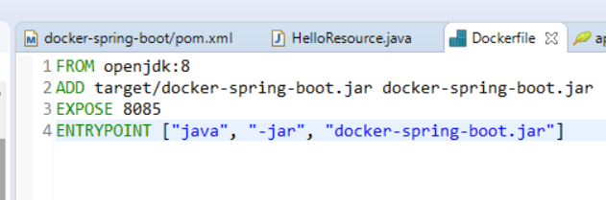

To build and run Spring boot application in docker, you have to execute following command in Terminal.

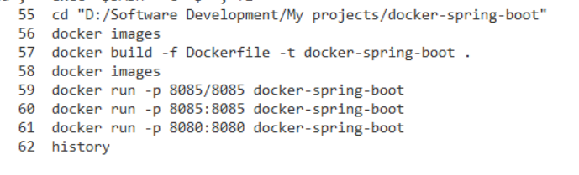

To stop the app, Cntl + c

**Docker was very slow to response**, restarting docker-machine helped.

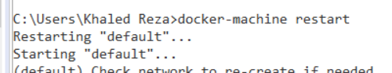

It was not restarting anymore. To make it work, I have deleted all environment variables, then it restarted everything by starting Docker quickstart terminal from start menu. Then environment variable got auto set again.

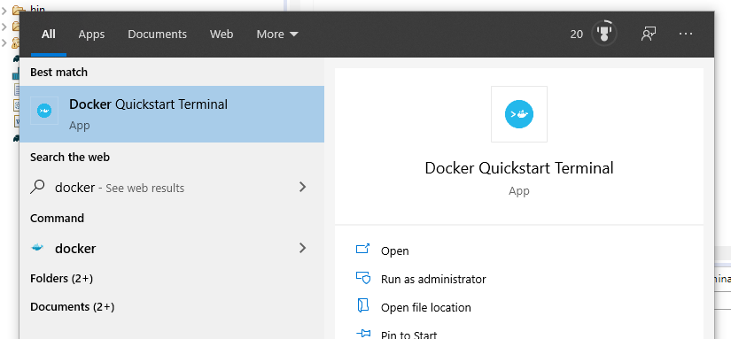

**Spring Boot app + Postgres in Docker**

openjdk and postgres dockerizes software sources was already downloaded by **docker pull postgres.**

Now, images can be seen by following. Docker-spring-boot was my first spring boot dockerized app.

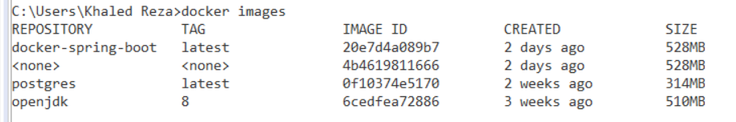

Created container with user, password, db name,

docker run --name postgres_container -e POSTGRES_PASSWORD=Salmon.138 -e POSTGRES_USER=postgres -e POSTGRES_DB=tradedb -d postgres



To see the new generated container,



How to write query for creating db and more queries on Postgres console,

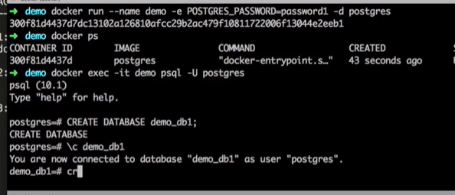

**Now, we need to create Spring Boot .jar and a container linked with this Postgres container.**

docker container ls

docker image ls

cd "D:/Software Development/workspace_18_5_2020/myStockDataSaver2"

**Run my Docker file and make image named “mystockdatasaver_app”**

docker build . -t mystockdatasaver_app

docker image ls

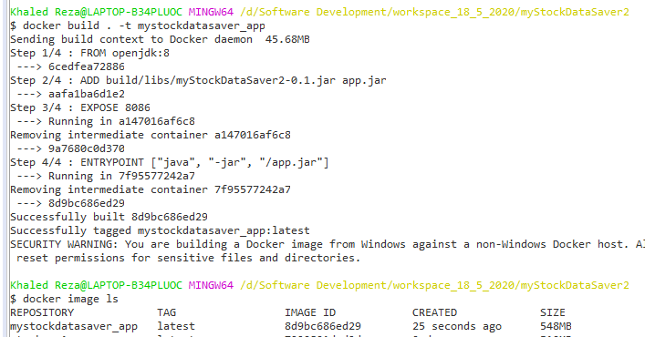

**Now, make docker container for my .jar file with the link of my postgres_container,**

docker run -p 8086:8086 --name mystockdatasaver_app --link postgres_container:postgres -d mystockdatasaver_app

docker container ls

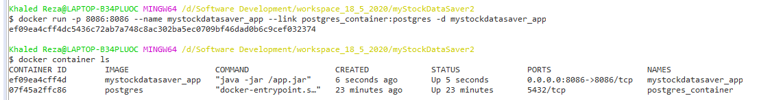

**We need to start postgres_container first, then my dockerized app which is linked with postgres,**

docker logs postgres_container

docker logs mystockdatasaver_app

now, it should be possible to access our data by localhost 8086, as configured.

**To Stop the app,**

docker stop mystockdatasaver_app

docker stop postgres_container

**To see the command history,**

History

**To see even hidden container,**

docker container ls –all

**To see which container is currently running on which port,**

docker ps



It was showing an error connecting postgres database because postgres_container1 was not correctly configured. Changing this code and generating .jar again. Then make new container using it helped.



First it did not work but after next try with the same command, it worked properly.

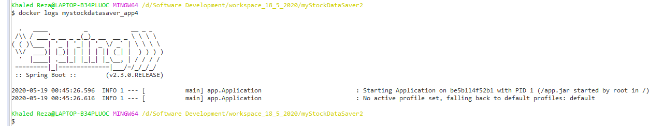

You can get your service now under, <http://192.168.99.100:8086/multiStockAssigner/getDownloadingSymbolList>

# [How can you find out which process is listening on a port on Windows?](https://stackoverflow.com/questions/48198/how-can-you-find-out-which-process-is-listening-on-a-port-on-windows)

netstat -aon | find /i "listening"

netstat -ano | findStr "8080"

netstat -aon | find /i "listening" |find "port"

# netstat -aon | find /i "abhören" for german

**Eclipse**

Eclipse , when there is an error in the project, it always listed in the markers.

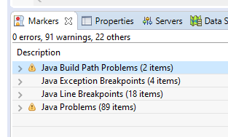

# [Can't start Eclipse - Java was started but returned exit code=13](https://stackoverflow.com/questions/11461607/cant-start-eclipse-java-was-started-but-returned-exit-code-13)

There are working combinations of OS, JDK and Eclipse bitness. In my case, I was using a 64-bit JDK with a 32-bit Eclipse on a 64-bit OS. After downgrading the JDK to 32-bit, Eclipse started working.

**Use one of the following combinations.**

* 32-bit OS, 32-bit JDK, 32-bit Eclipse (32-bit only)
* 64-bit OS, 32-bit JDK, 32-bit Eclipse
* 64-bit OS, 64-bit JDK, 64-bit Eclipse (64-bit only)

**PostgreSql**

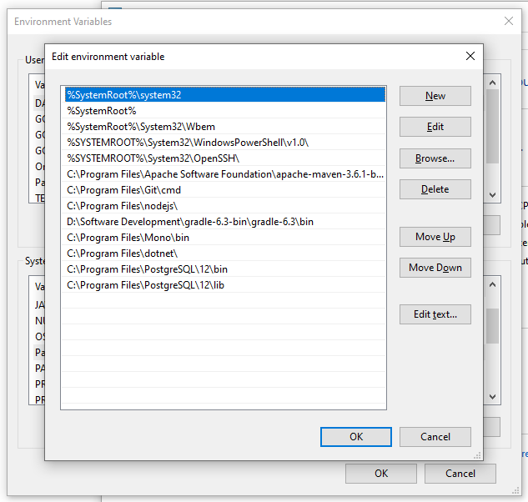

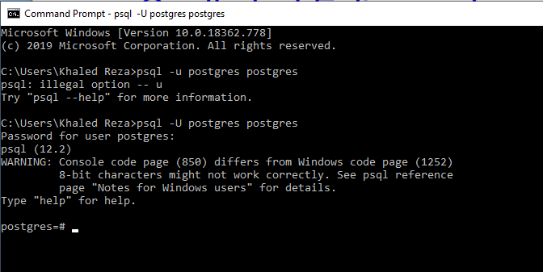

When postgre link is not properly configured in application.properties, then we get following

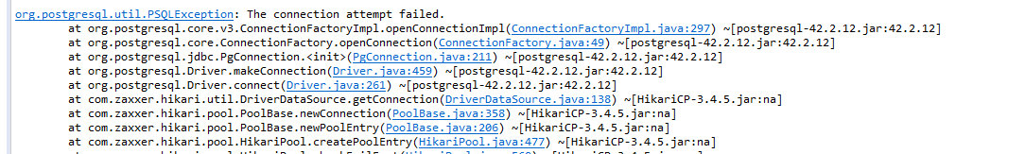

# Error/Solved Research

# ['Field required a bean of type that could not be found.' error spring restful API using Postgresql](https://stackoverflow.com/questions/42907553/field-required-a-bean-of-type-that-could-not-be-found-error-spring-restful-ap)

# Solved it. So by default, all packages that falls under @SpringBootApplication declaration will be scanned. By putting Application.java (below picture) into the com.example package just helped the problem solving. So Application.java should be upper folder than Repository and controller.

# 

**Changed project name by refactoring and now all class with error**

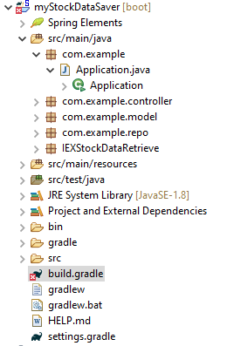

Restart eclipse helped. And finally to remove the build.gradle error, I had to clean two error listed on markers. Actually it just said that project root had some problem which was mentioned in settings.gradle

**Spring New instance creation problem, null, exception**

I am trying to create new instance but every time it found SingleStockRunner (a containing multithreading) the data null. I think some Spring core object wiring problem

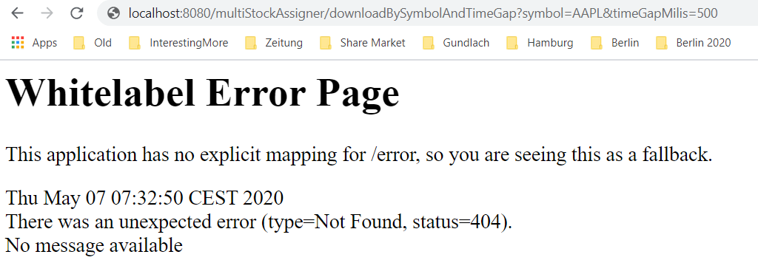

That means application is running but the link here what you wrote here is not present in your Rest mapping.

**Error to start the Spring boot app with following message**

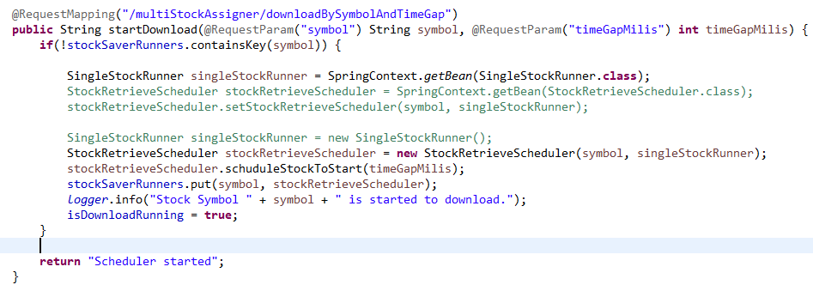



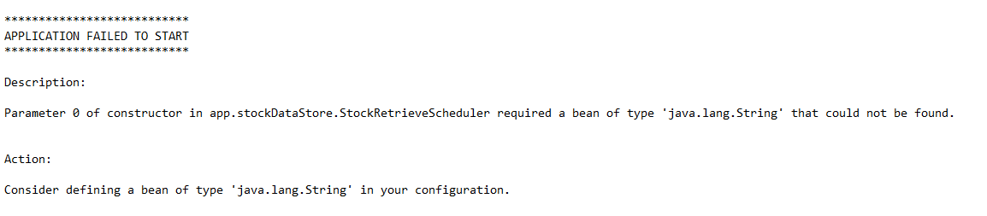

The problem was it could not generate instance of a StockRetriveSchduler class.

Solution: Get the @Component Bean by a special class SpringContext (find in the below)

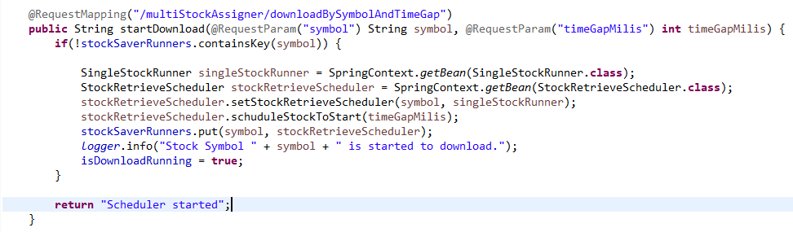

Add a setter instead of constructor.

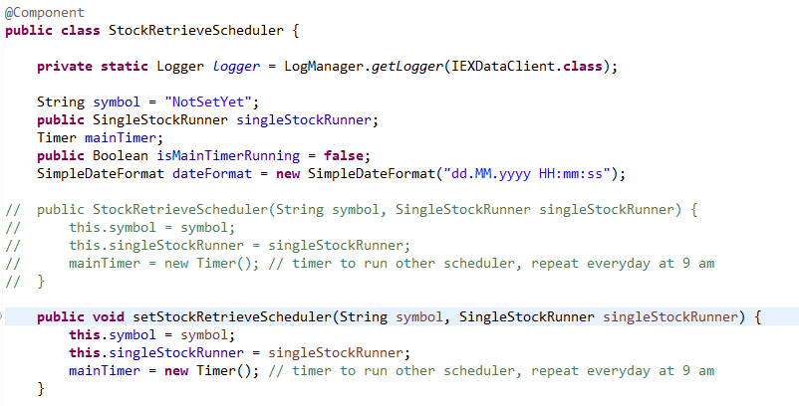

Using this technique, now it can generate new instance of any @Component or class.

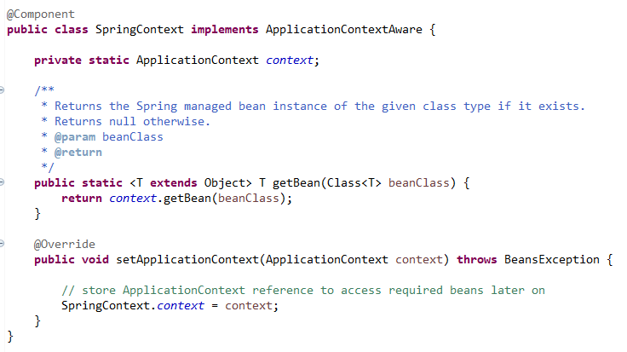

**Spring Boot new project**

First tried download from online Spring starter. It made and then I imported in my project but it did not download the dependencies properly for gradle.

Then locally, I tried to make a new project with (gradle, Spring boot, jpa, postgresql, spring web) Spring starter. Probably I changed some name or artifact. It did not work in old workspace (it always remember the same) and when I made it in new workspace, then it worked.

**Dealing with make a jar with dependencies did not work**

It was not possible to build a make a jar with all the dependencies.

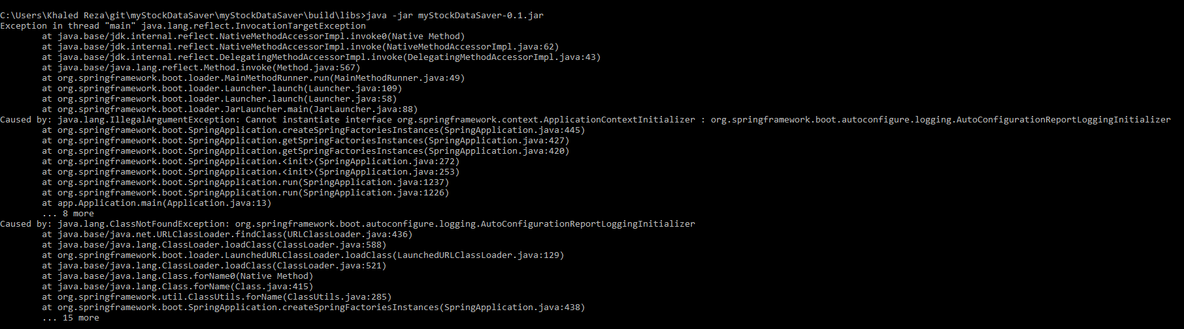

[**Gradle - How pack dependencies into jar**](https://stackoverflow.com/questions/25405006/gradle-how-pack-dependencies-into-jar)

**gradle Exception in thread "main" java.lang.NoClassDefFoundError: org/springframework/boot/SpringApplication at app.Application.main(Application.java**

**And second Failure message was, cannot find configuration file from META-INF.spring.factories file missing.**

Now, after talking with Rubel vai, I am going to move my code to a new project part by part and execute and then I want to see where is the problem.

First, tried to build a project with one basic Hello rest method. It worked. To make it executable with dependencies, I had to execute gradle task with bootJar. It worked perfectly both starting and browser.

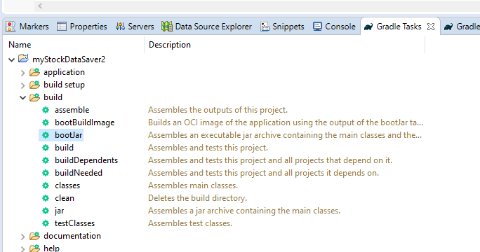

Then I started to move my code there. After moving all code without test, executing bootJar, it worked perfectly both starting and browser.

Then I moved all the Test files, and executed the entire tests. It did not worked. Some of them for right reason. I resolved the problem. When I executed bootJar again (before test resolving) it did not generated new Jar file. Afterwards, I did a clean execution from gradle tool. Then executing bootJar it generated the new jar which worked perfectly both starting and browser.

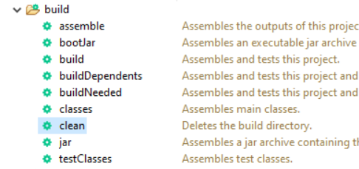

Finally I resoled all the failed test. It was a problem of Spring boot.

**Mockito**

**How to mock a repository? How to provide a service with many Autowired object? We have to initialize MockitoAnnotations.initMocks(this)**

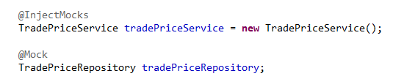

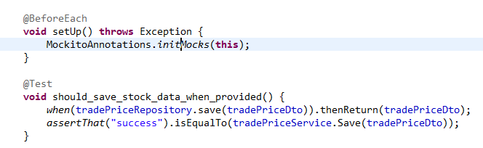

**Bug on Spring boot application running**

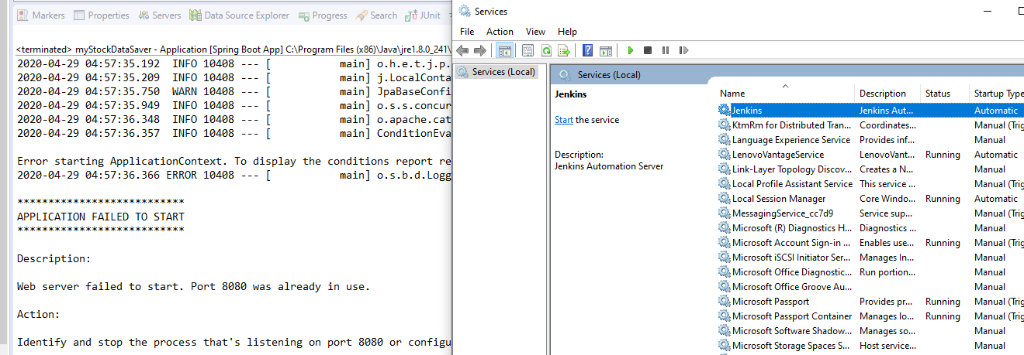

**Spring boot has predefined query writing way.**

<https://docs.spring.io/spring-data/jpa/docs/current/reference/html/#repositories.query-methods.query-creation>

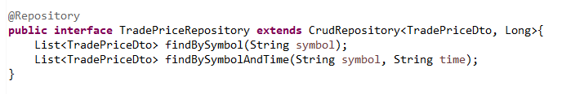

When it runs, it will tell if query method name valid according to table structure. If it is valid, it automatically generates query for you. When table is not exist, it even creates table.

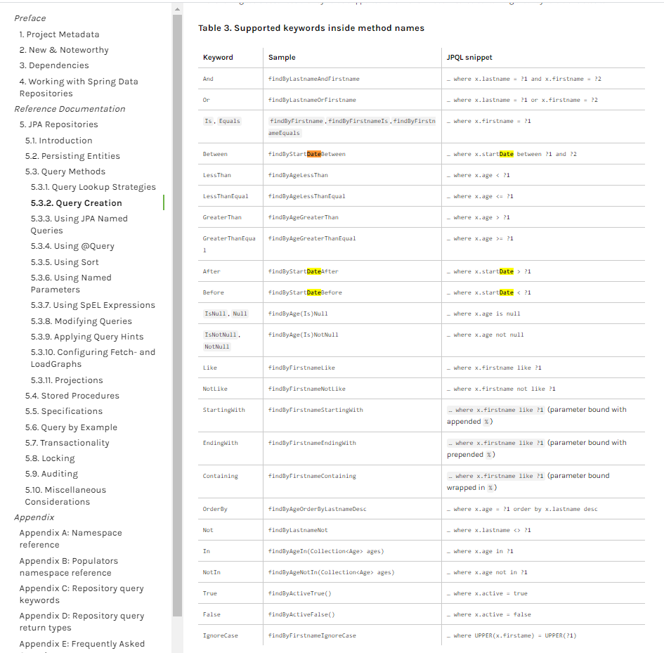

# Java Spring Boot + Postgresql + Hibernate + Crudrepository (It is important to keep the hierarchy of the file)

# 

# 

# 

# 

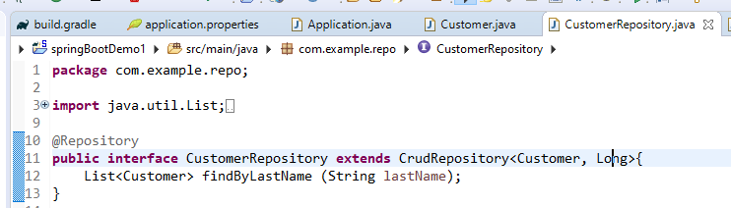

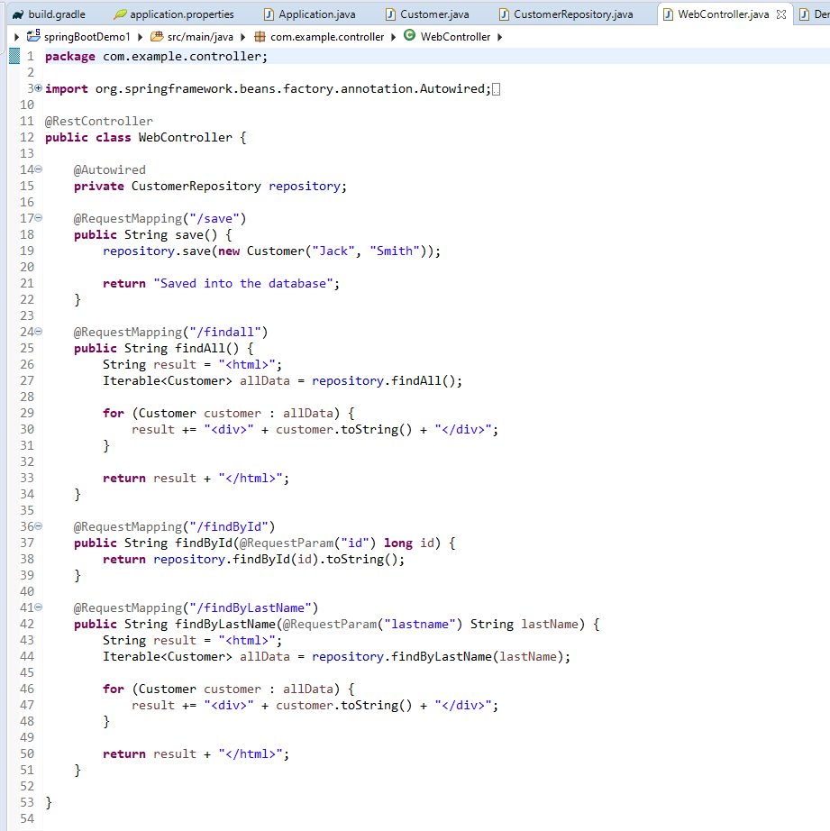^

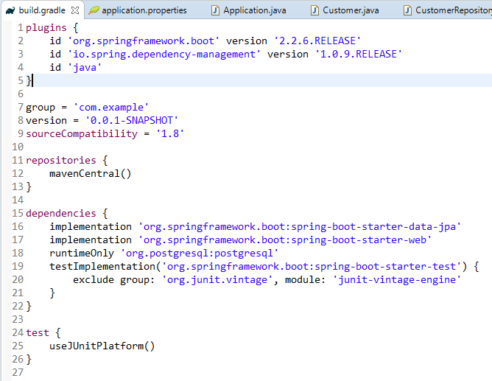

**Spring Core Annotations**

In core spring, you have to create bean in bean.xml and to give your Class bean access to all other class.

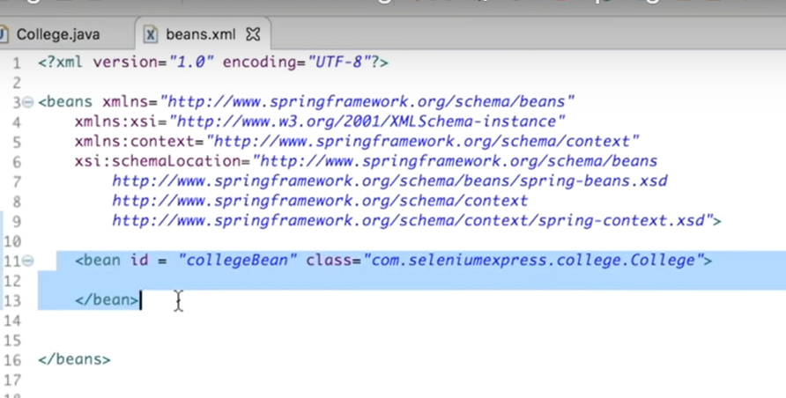

It generates collegeBean in IoC container which could be accessible from other class by getBean(“collegeBean”)

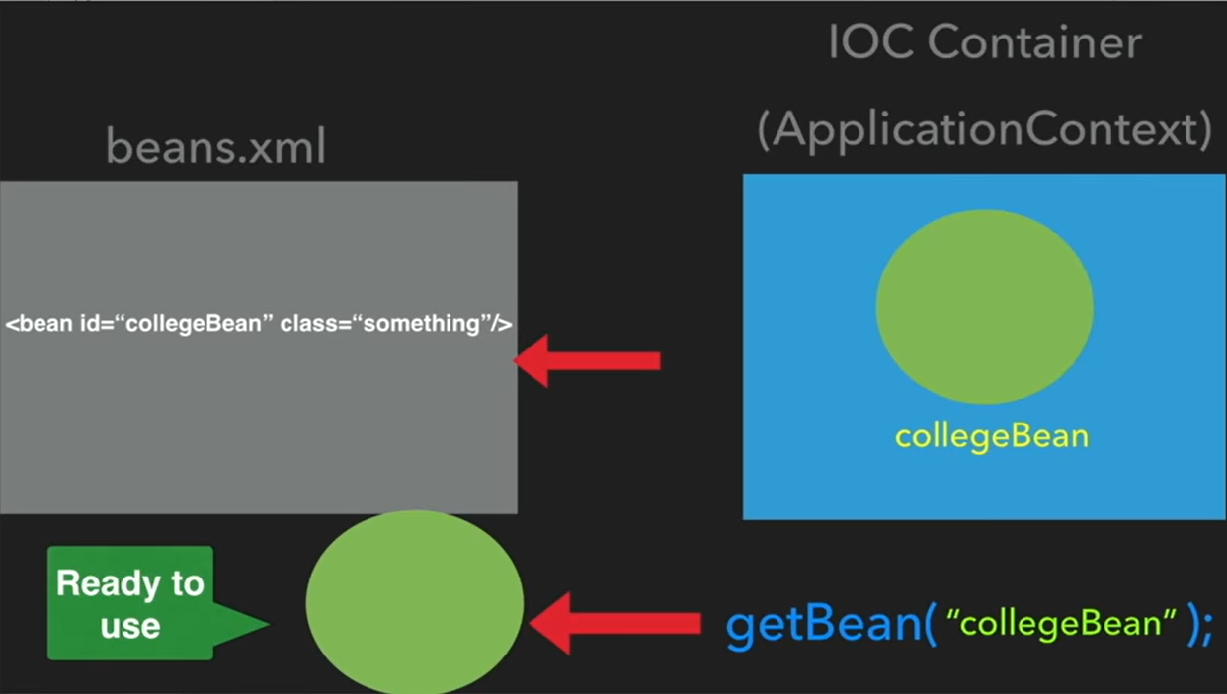

Other way,

Instead I can create an annotation @Component. It will create an object. It will be exactly do the same like bean and we can get rid of xml file.

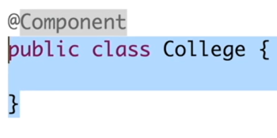 and we can give Id like this, “collegeBean” 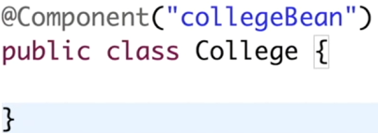

When it is considered like without bean Id, then it will take default bean id which is **college** (only the first letter small letter from the class name)

For that we have to add that base package info where College belongs in the Bean.xml file with componentScan,

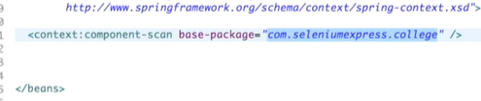

If we want to remove that xml file completely and use ComponentScan in Java end, we have to create another file called Config file with @Configuration annotation. We need to add @ComponentScan with basePackage.

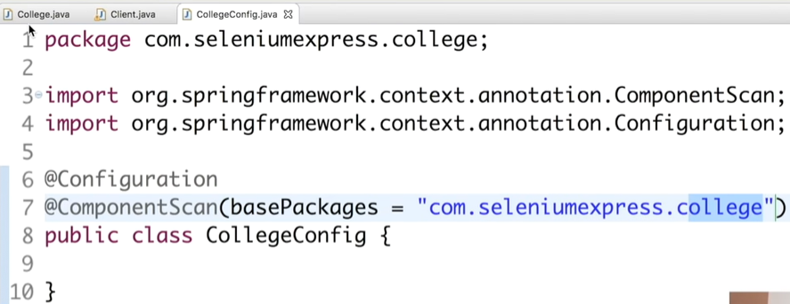

For that we have change our ApplicationContext now. Now we are not reading anything from xml file, rather we read from Annotation. So we add there AnnotatonConfigApplicationContext context = new AnnotatonConfigApplicationContext(CollegeConfig.class) with that newly genereated config file. Context must be closed at the end.

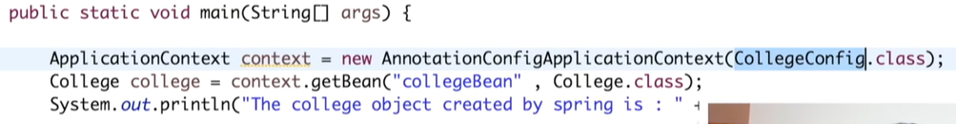

Another way to create Bean is, @Bean. Inside the configuration file, we can generate a bean that will return a new object of that class. Default bean id is **collegeBean** based on name**.**

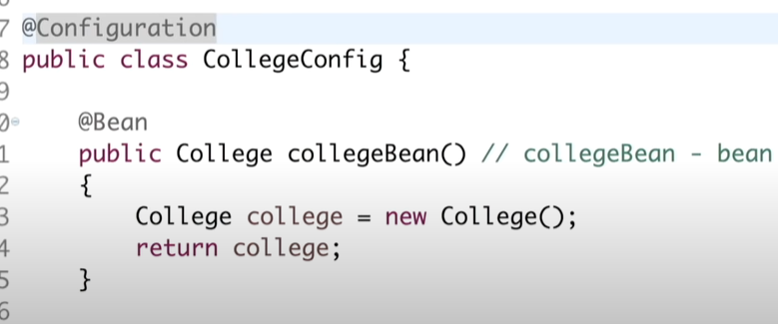

Now, it will work without @Component annotation.

It is possible to provide Bean id with this annotation (even multiple), with that it will be possible to read it from anywhere as before we did in ApplicationContext in main file.

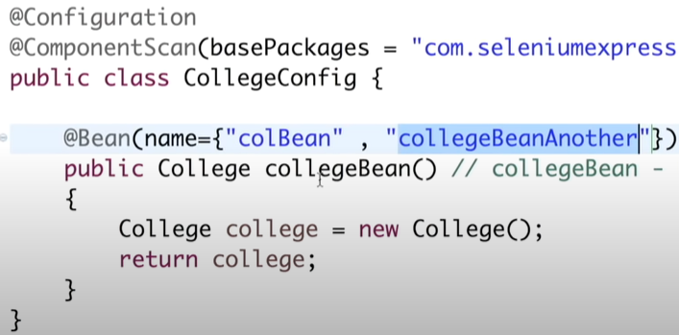

**Dependency Injection**

When we need dependency to inject we can use @Bean Configuration setting. So, there is no annotation needed for Principal object and it automatically initiates in the config file. So principle.prinipalInfo() method will work. This is manual way.

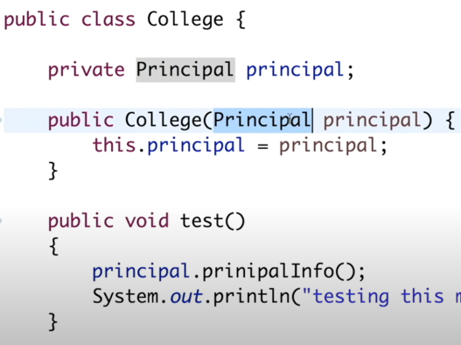

We can make more @Bean to inject one to other manually.

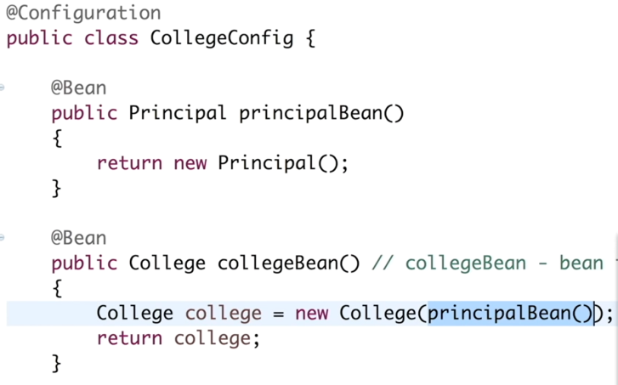

**Now, how to inject Interface,**

We have an interface Teacher

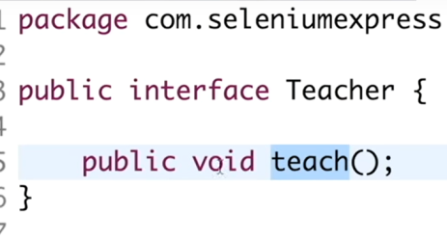

MathTeacher class implements that teacher Interface. There is only one implementation of Teacher, that’s why it will automatically choose it to apply when that interface and the method teach called.

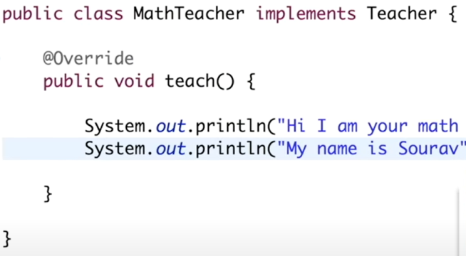

Here three beans are defined and one bean is defined collegeBean() which is used in the Application file to get all the config.

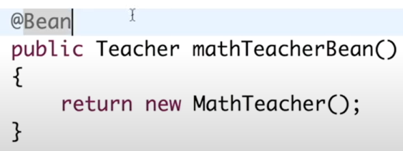

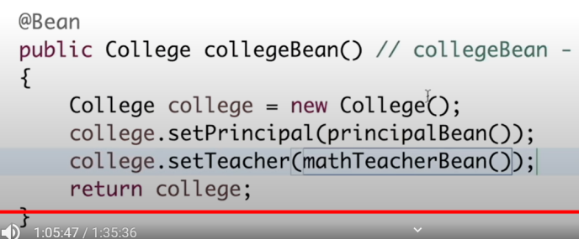

**Now, how it will look like if choose @Component annotation to do this work (@Bean), here in the College class @Component added.**

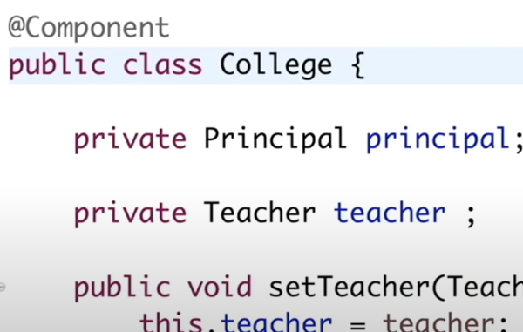

Now the bean name is changed, “college” based on the college Class name.

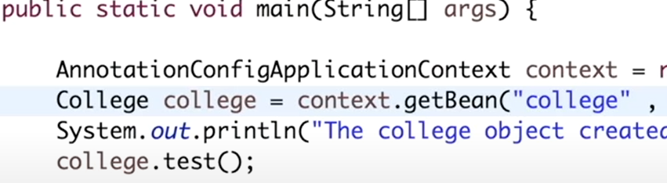

In the configuration @ComponentScan is added, and all @Bean are commented out.

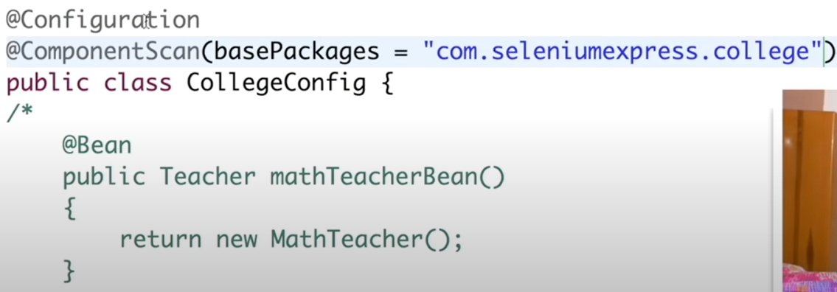

So, now add @Component to Principal, so that it can be discoverable too.

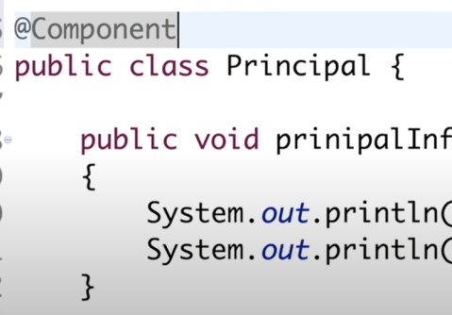 Also add for 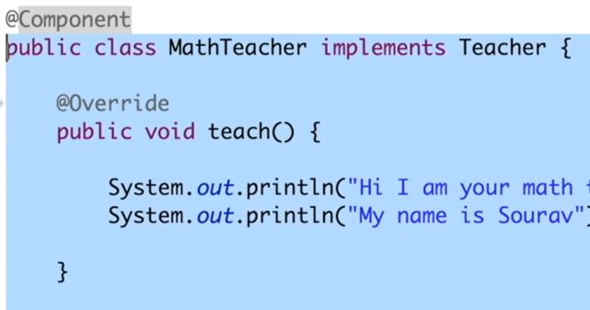

Now @Autowired added in the College Class. It can be added to set method too. But it is better to put on the class declaration.

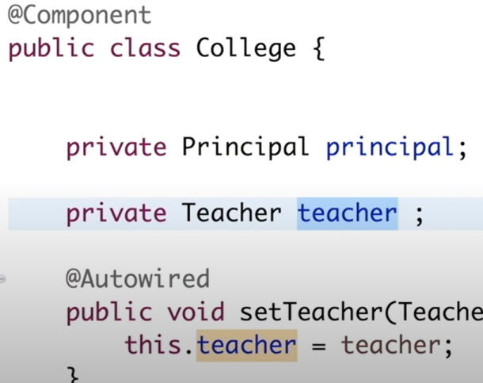 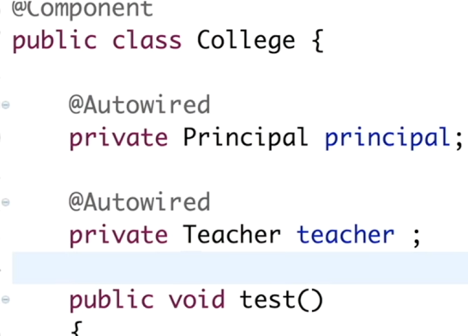

Now, if we provide more implementation for Teacher interface,

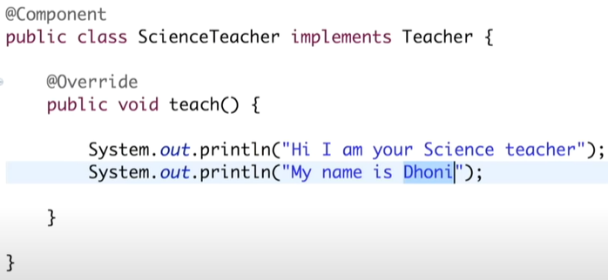

We can set one Implementation @primary, then always it will be by default used when instantiated.

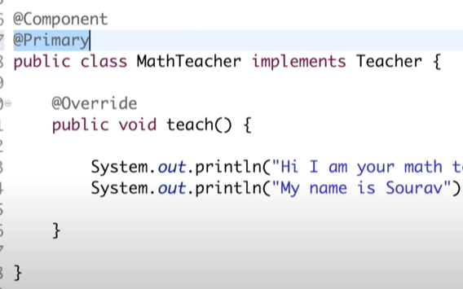

But if you want to use another implementation, we must use @Qualifier with the bean name (scienceTeacher) of that implementation.

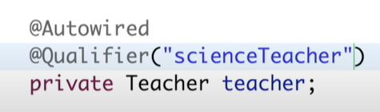

We can assign String or Integer value like this. Then you can use it as normal assigned variable.

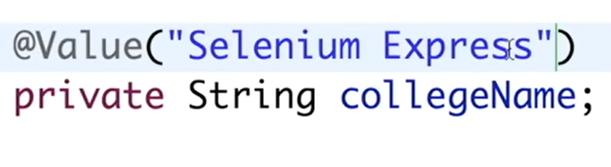

To read configured data from property file we need to generate a properties file to provide data. It should be under src file as following,

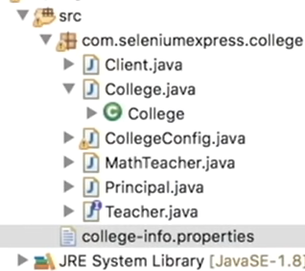

**Then write some variable like this,**

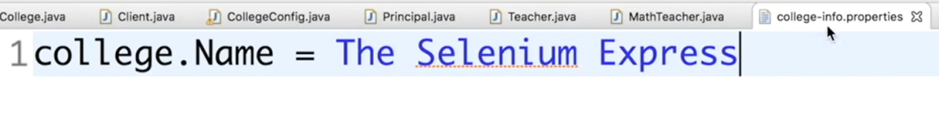

Added newly created property file should be given in the configuration file.

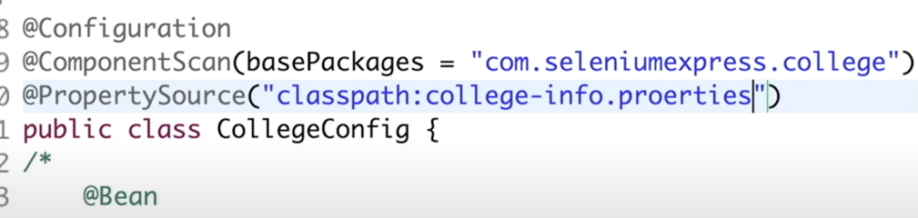

This variable is now accessible by this variable.

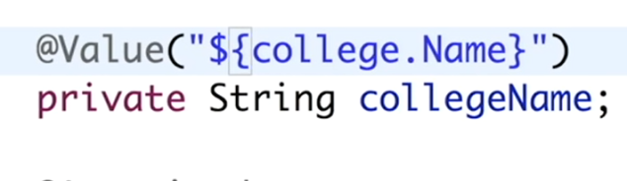

**If any object needed to be not null, we can use @Required annotation.** If user doesn’t provide this variable by setCollegeName, then this application will give an exception now.

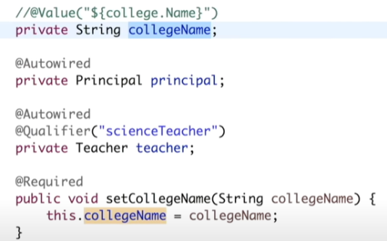 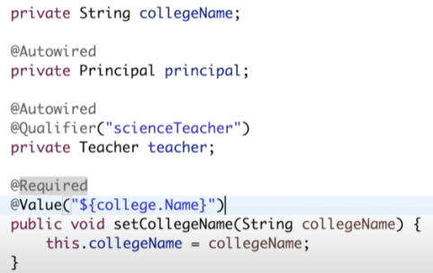

@value (${college.Name}) should be put on top of setCollegeName to run it perfectly.

**While executing this application, we'll use *applicationContext*object and call its *getBeanDefinitionNames()*method, which will return all the beans in our *applicationContext*container:**

|  |  |
| --- | --- |
| 1  2  3  4  5  6  7  8  9  10  11  12  13  14  15  16 | @SpringBootApplication  public class Application {      private static ApplicationContext applicationContext;        public static void main(String[] args) {          applicationContext = SpringApplication.run(Application.class, args);          displayAllBeans();      }        public static void displayAllBeans() {          String[] allBeanNames = applicationContext.getBeanDefinitionNames();          for(String beanName : allBeanNames) {              System.out.println(beanName);          }      }  } |

This will print all the beans from *applicationContext*container:

**How to set Port number in Spring boot project,**

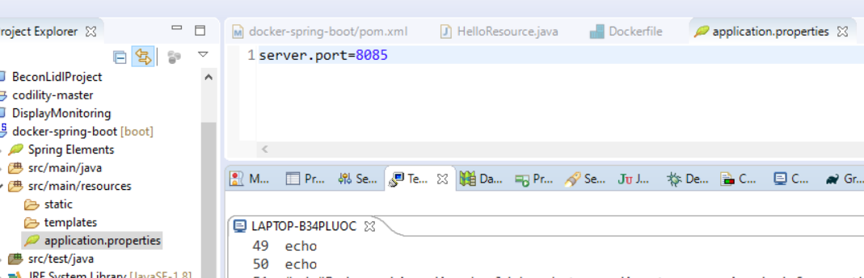

**Problem to solve**

Trade Open close time db was not implemented

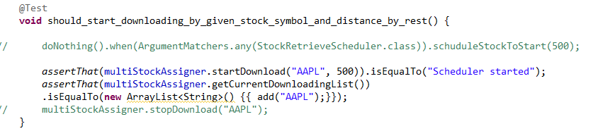

It did not started the time 15.30 that should download

